| **No** | **Subject** | | **Page No** |
| --- | --- | --- | --- |
|  | | | |
| **1** | **Introduction** | | |
|  | **1.1** | **Introduction** | **01** |
|  | **1.2** | **Problem Definition** | **01** |
|  | **1.3** | **Scope of Project** | **01** |
| **2** | **System Design** | | |
|  | **2.1** | **Use Case Diagram** | **03** |
|  | **2.2** | **Class Diagram** | **06** |
|  | **2.3** | **Interaction Diagram** | **07** |
|  | **2.4** | **Activity Diagram** | **07** |
| **3** | **Coding Standards** | | **08** |
| **4** | **Screen Shots of the project** | | **10** |
| **5** | **Visualization of Results** | | **20** |
| **6** | **Accounting Report** | | **24** |
| **7** | **Inventory Report** | | **41** |

# Introduction

**Objective of the Project:** ERP System to Manage Purchase, Manufacturing, Inventory, Sales, Accounting, and Dashboard.

**Project Category:** Web Application

**Front End:** Odoo 15.0, Python

**Back End:** PostgreSQL

# Problem Definition

* Users need help with data backups on the application.
* absence of a dedicated Web Application for Multi Branch and Small Business product management Systems.

**Existing System:**

| **Software** | **Website Link** |
| --- | --- |
| **Letstranzact** | https://resource.letstranzact.com/ |
| **Nestorbird** | https://nestorbird.com |
| **Accountserp** | https://accountserp.com/ |

**Need for the New System:**

* Mostly Existing Systems are Paid, and not Affordable for Small Businesses.

**The objective of the New System:**

* be affordable for Small Businesses and help them to grow their business.

**Core Components/Modules:**

* Sales
* Purchase
* Inventory
* Manufacturing

**Project Profile:**

* **Platform:** Odoo 15.0
  + **Developer:** Devani Shani
  + **Resources & Testing:** Kaklotar Jaydeep & Patel Akshitkumar
* **Advantages and Limitations of the Proposed System:**
  + **Advantages:**
    - Low cost
    - Easy to use
    - Multi-Company(Branching)
    - Multi-User
  + **Limitations:**
    - Some time not working for windows
* **Targeted Users:**
  + Small Business
  + Big business
  + Multi-branch business
  + Manufacturer

## **Use Case Diagram:**

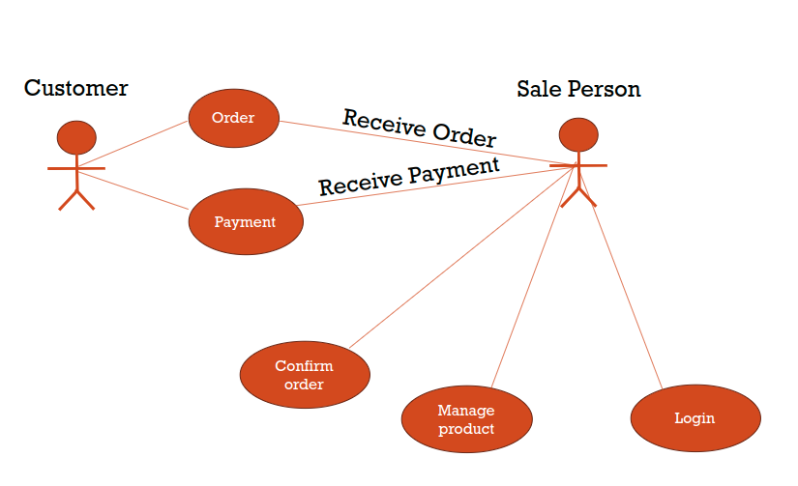

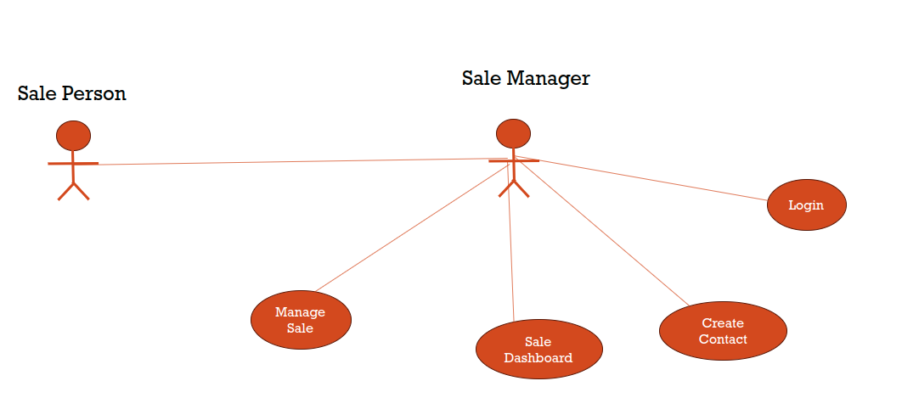

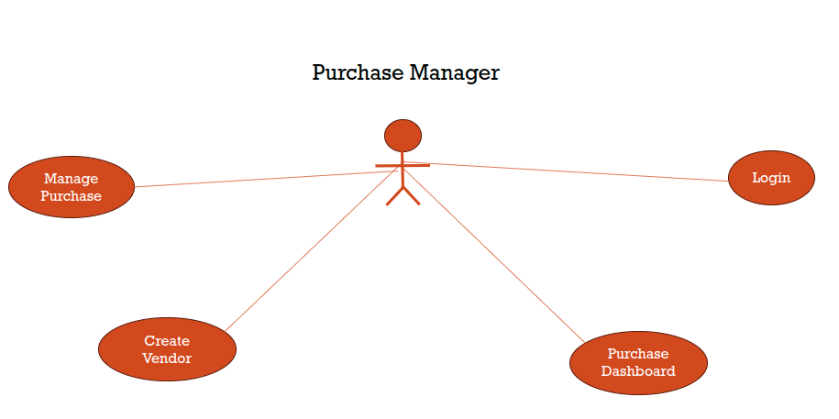

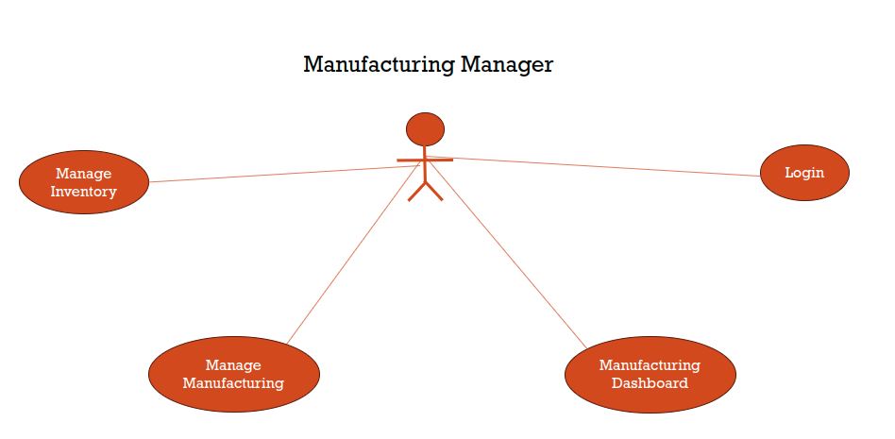

## 

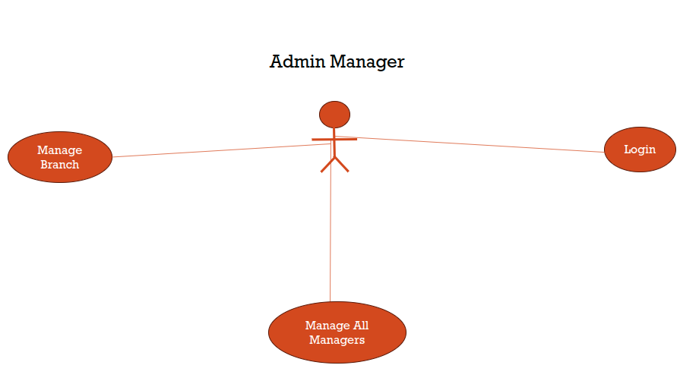

## **Class Diagram**

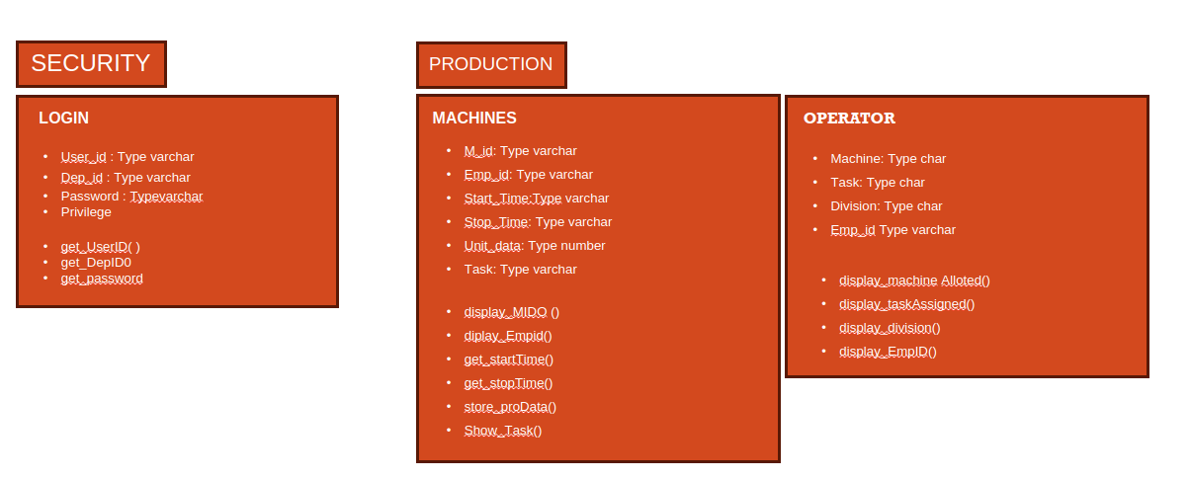

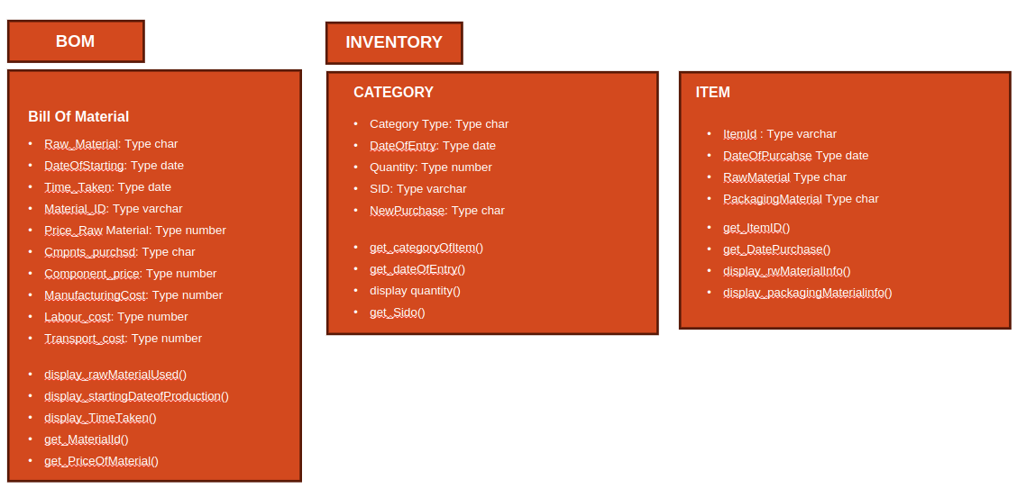

## **Interaction Diagram**

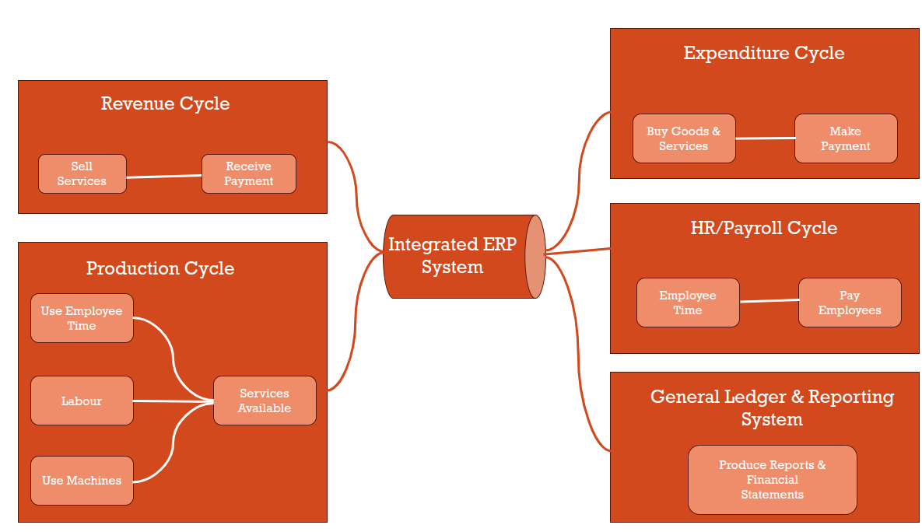

## **Activity Diagram**

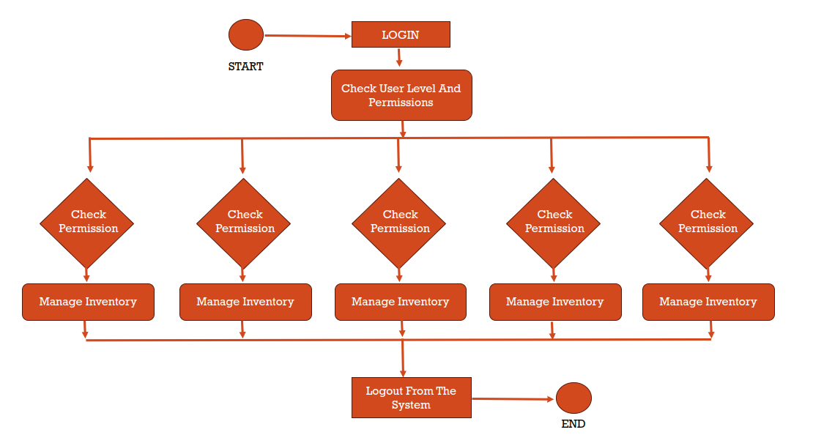

## **Coding Standards**

### **README.md**

* + Write a comprehensive README file that explains the project's purpose, how to set it up locally, how to run tests and any other relevant information.
  + Include badges for build status, code coverage, and other pertinent metrics.
  + Provide clear instructions on contributing to the project and the contribution guidelines.

### **Code Comments**

* + Use meaningful variables, functions, and component names to make the code self-explanatory.
  + Add comments to complex sections of code, algorithms, or where the code might not be immediately obvious to others.
  + Follow a consistent commenting style throughout the project.

### **Dependencies**

* + 'base', 'sale_management', 'account', 'CRM', 'stock', 'purchase', 'point_of_sale', 'mrp','hr_expense', 'hr_holidays', 'hr_recruitment', 'maintenance', 'hr', 'calendar', 'im_livechat', 'hr_attendance', 'lunch', 'hr_contract','ks_dashboard_ninja'

### **Folder Structure**

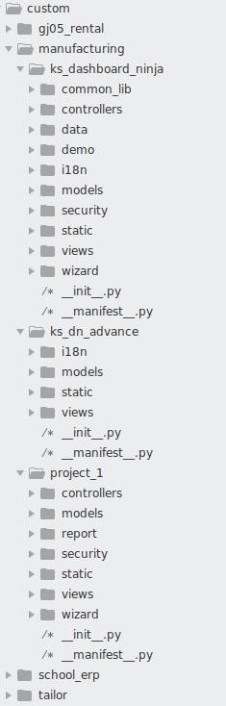

## **Screen Shots of the project**

### Login page

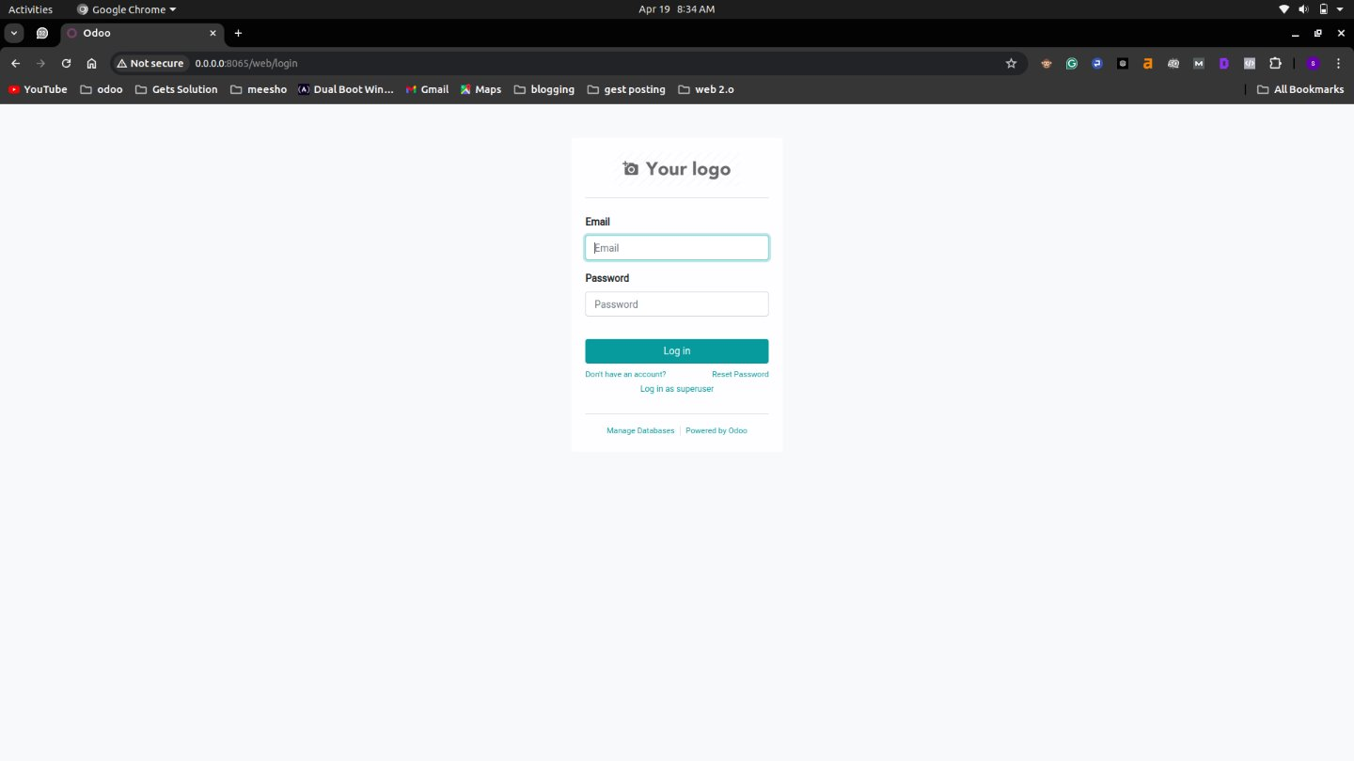

### Company list view

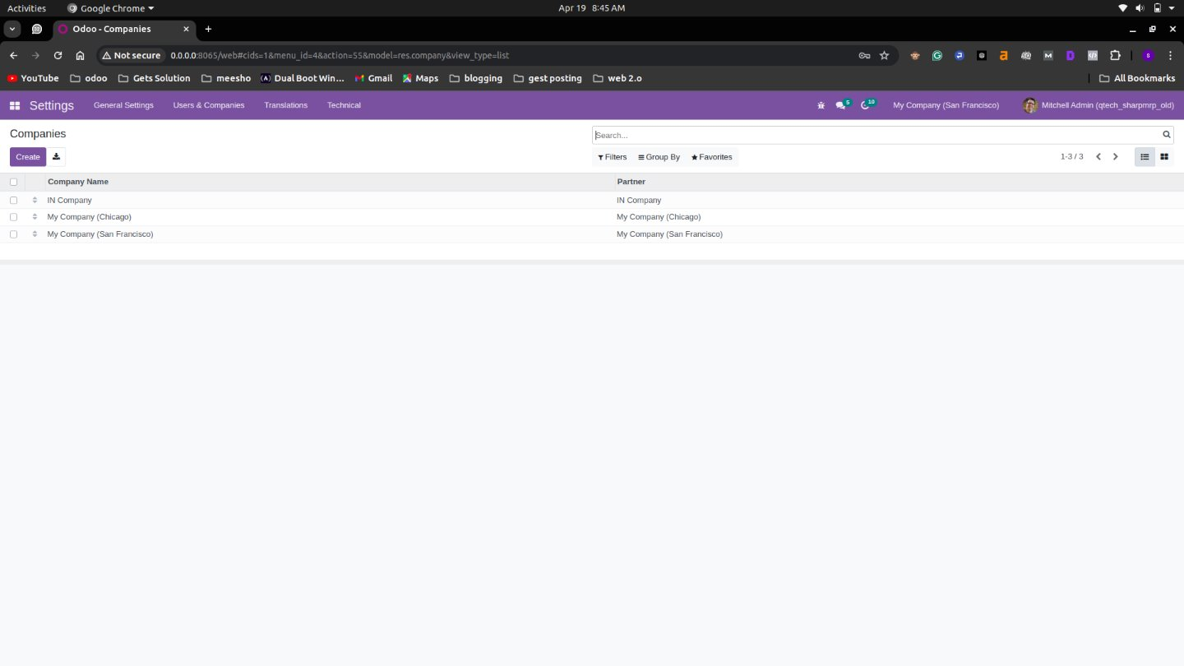

### Company from view

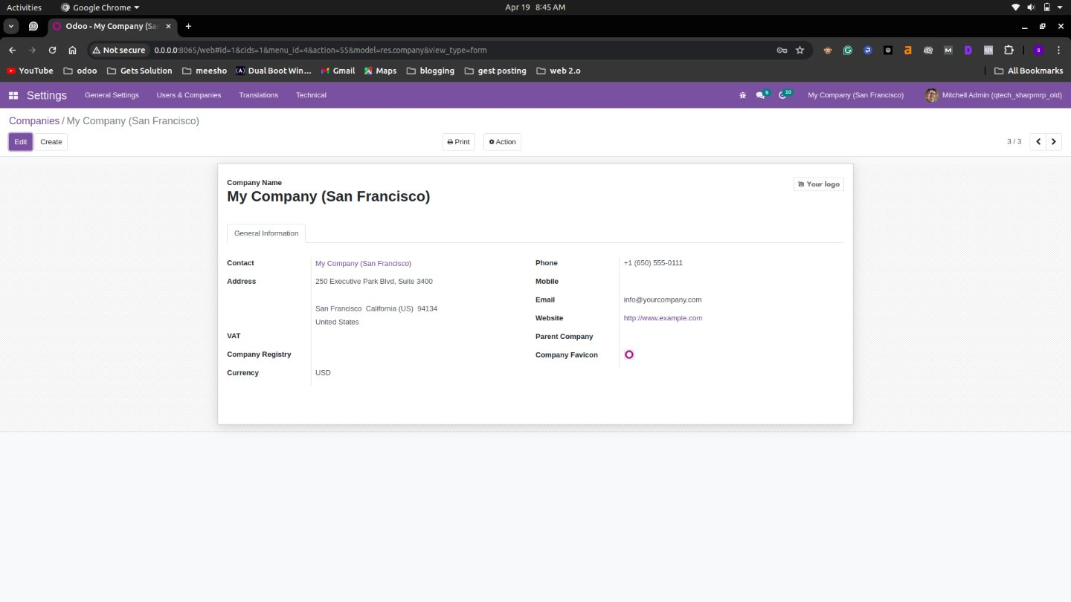

### User list view

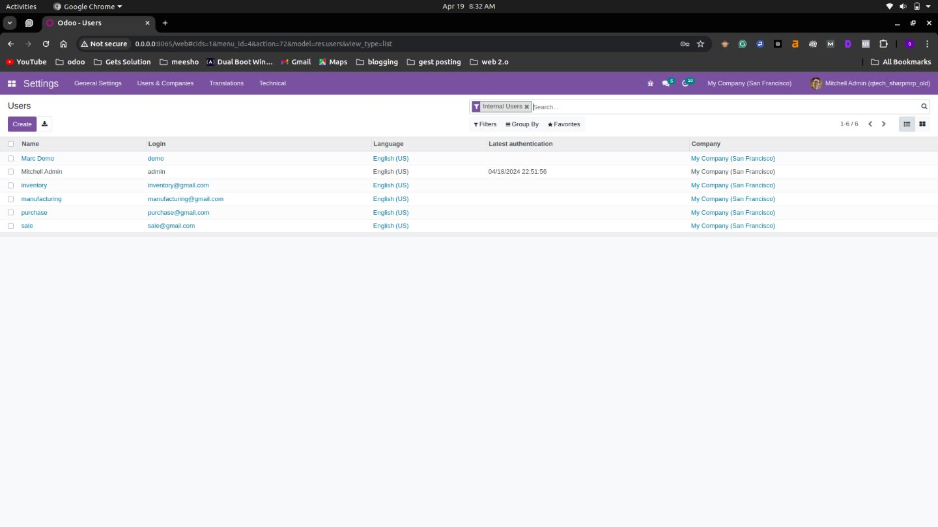

### User form view

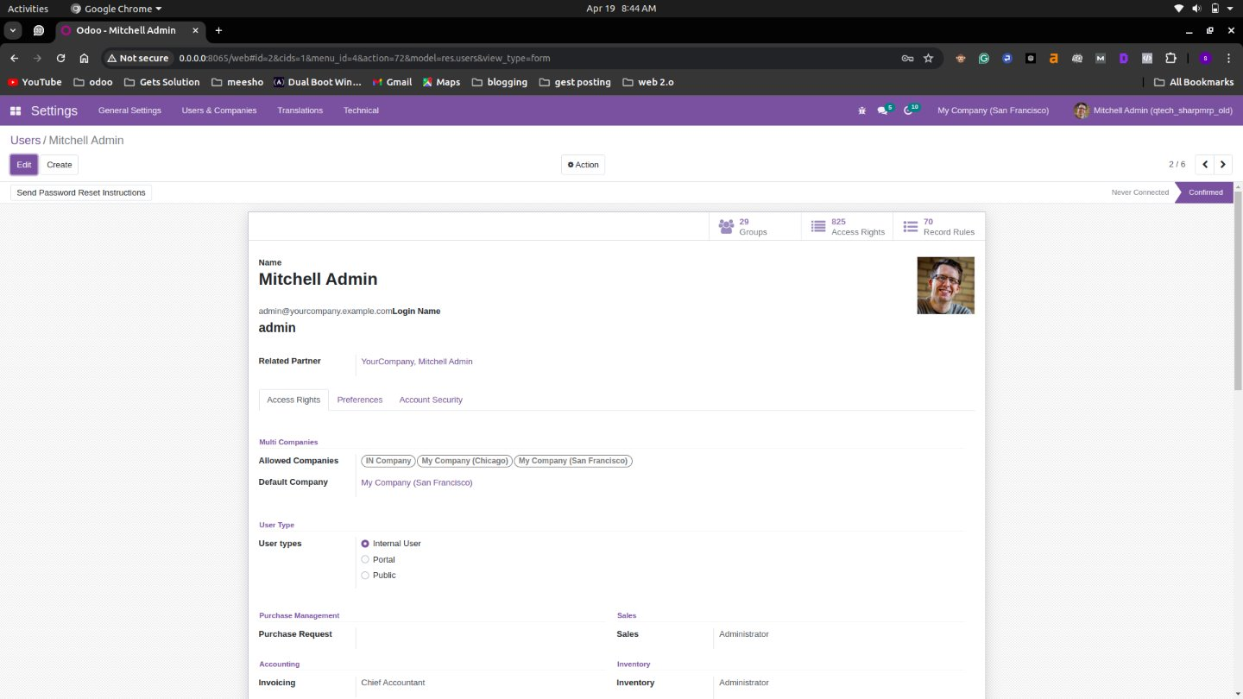

### Contact list view

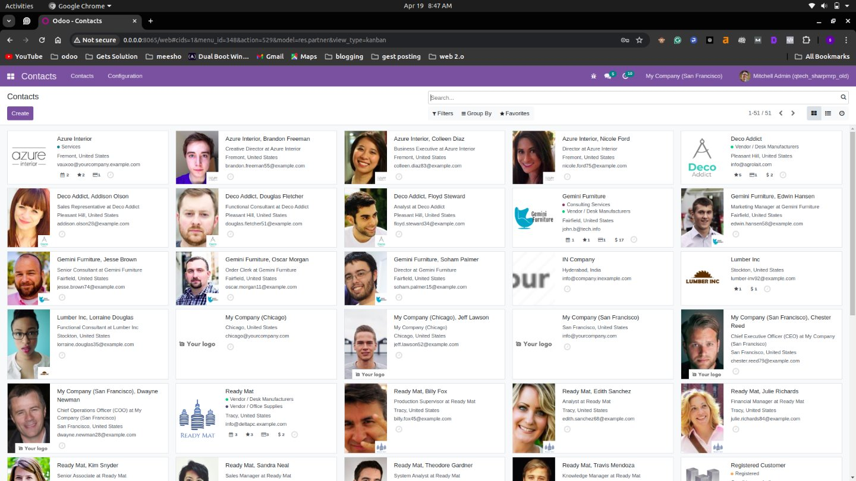

### Contact form view

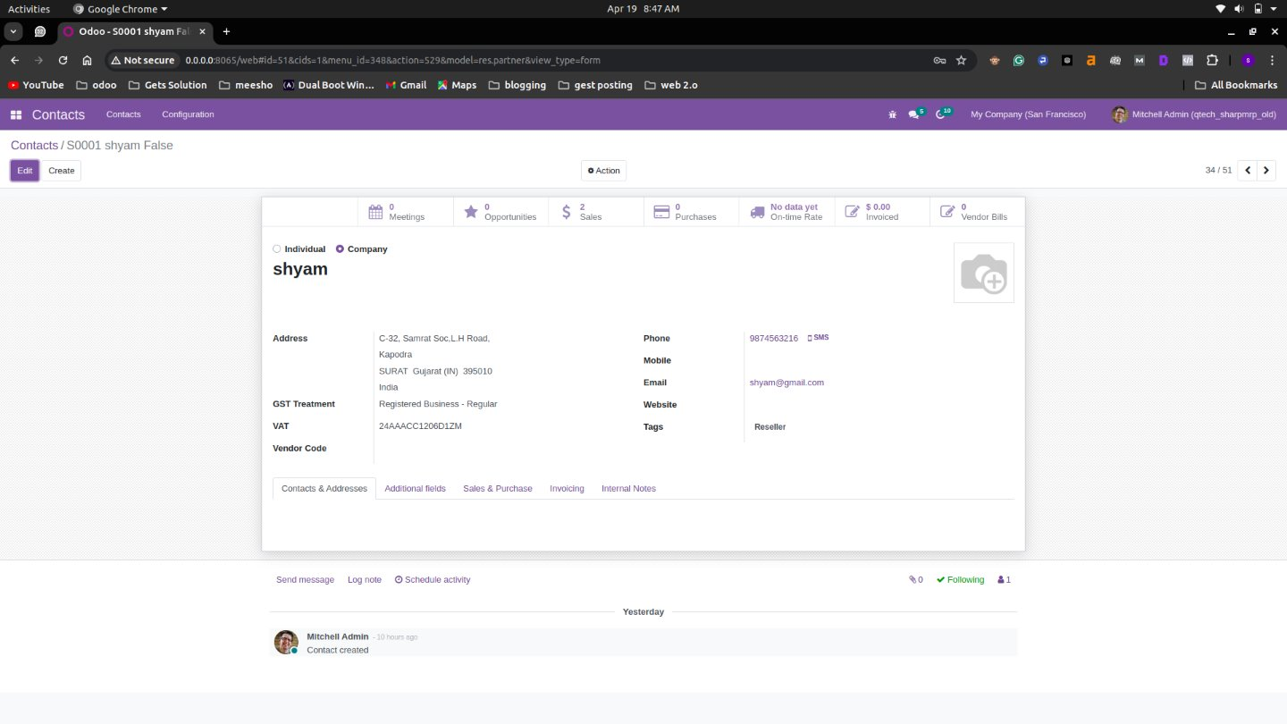

### Product list view

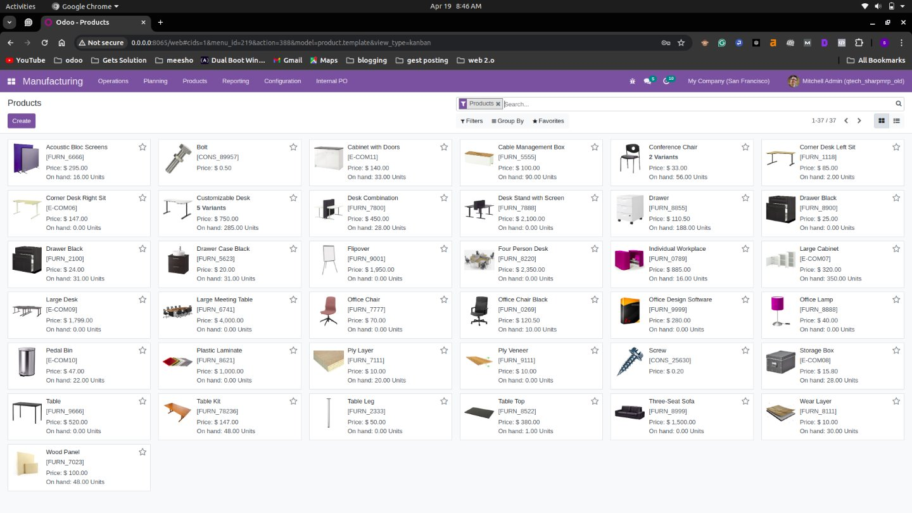

### Product form view

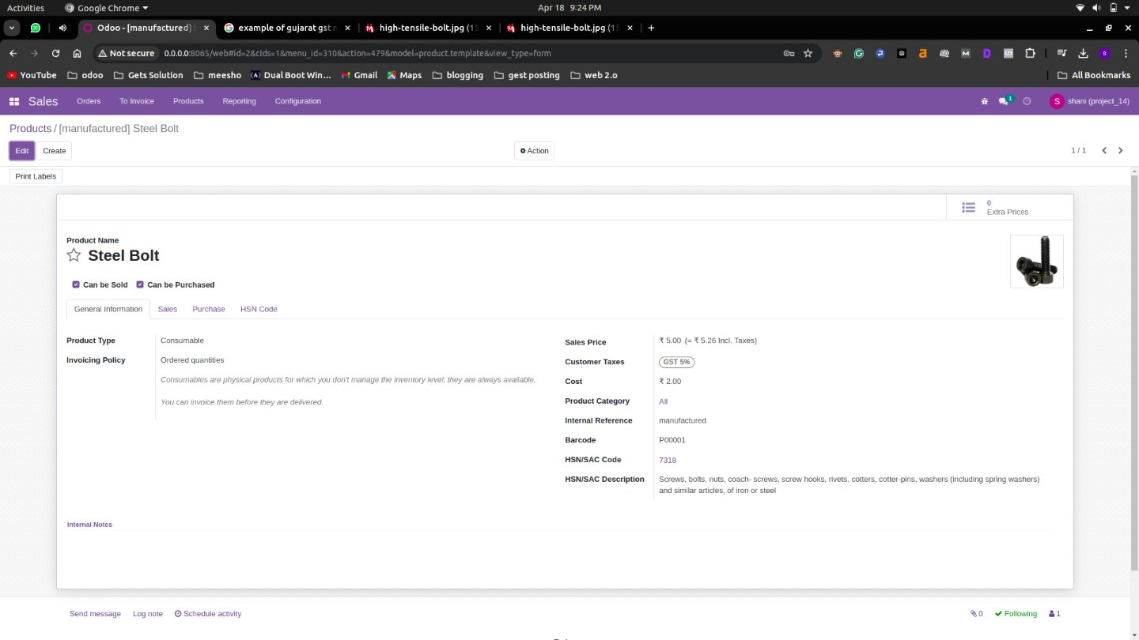

### Manufacturing list view

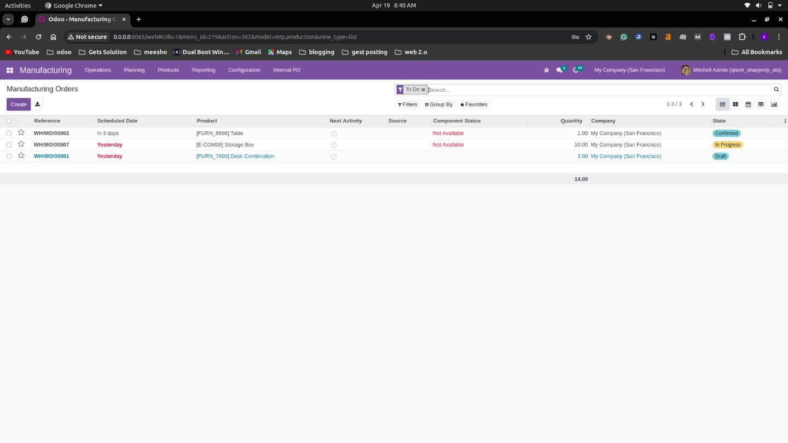

### Manufacturing form view

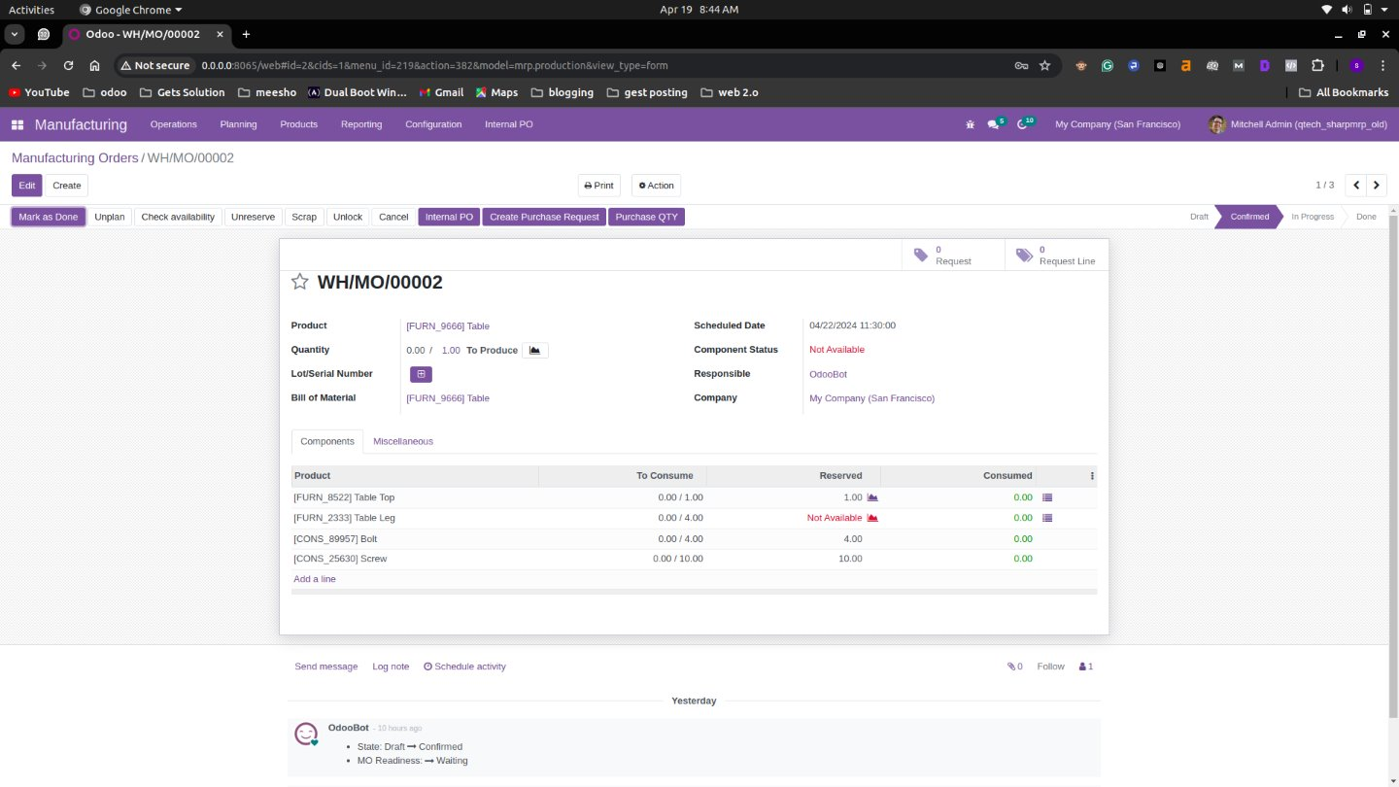

### Sales list view

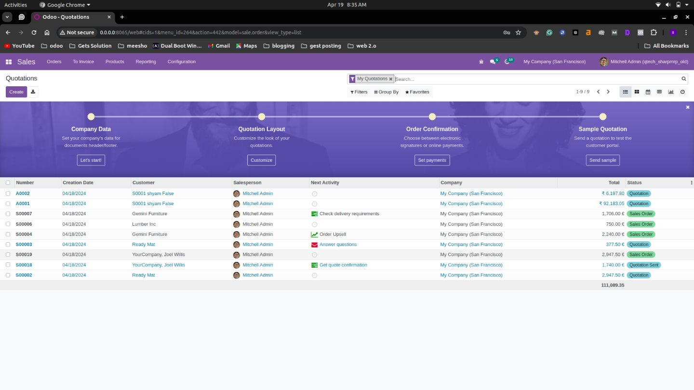

### Sale form view

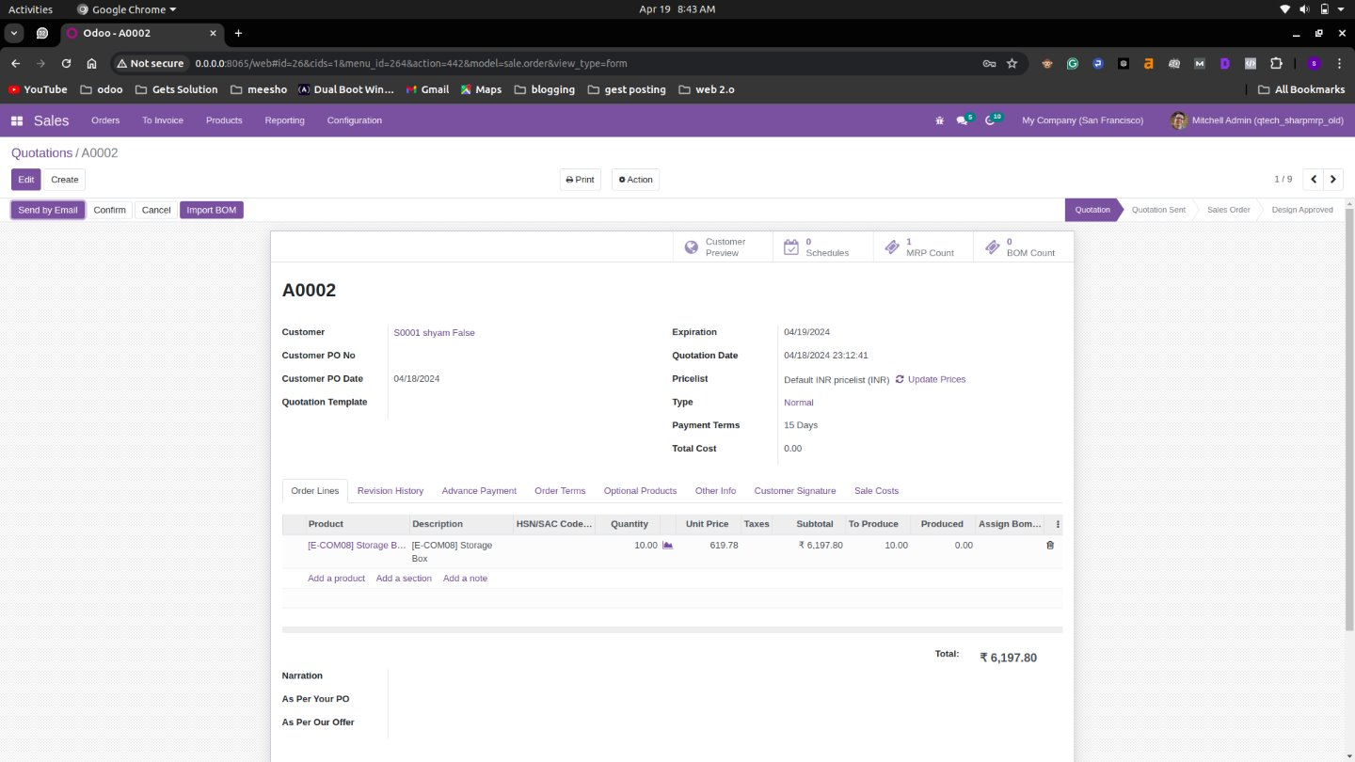

### Purchase list view

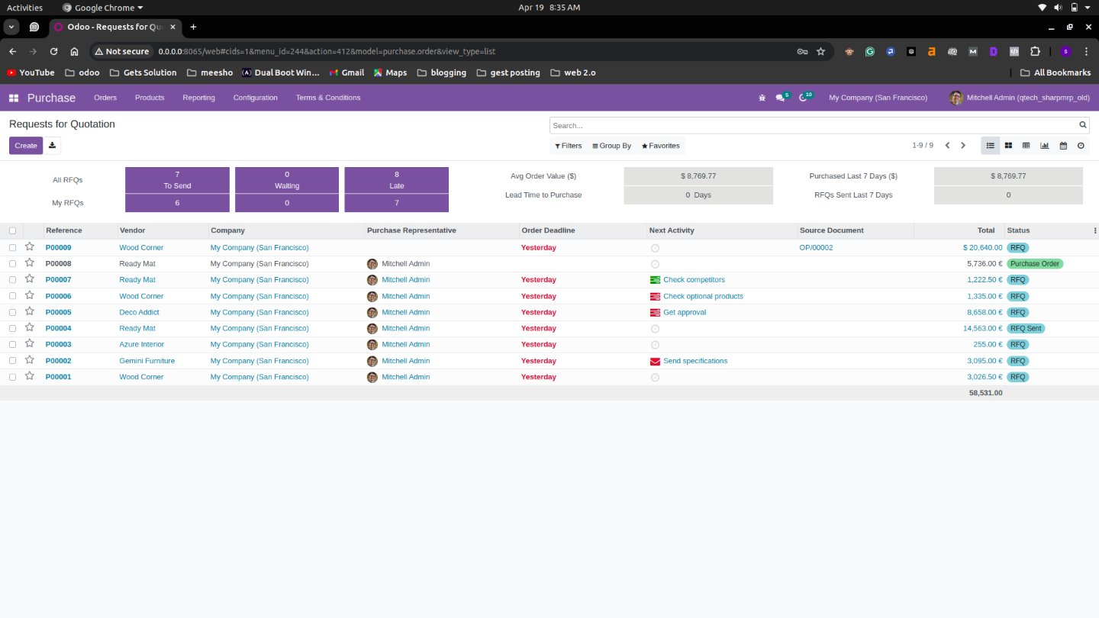

### Purchase form view

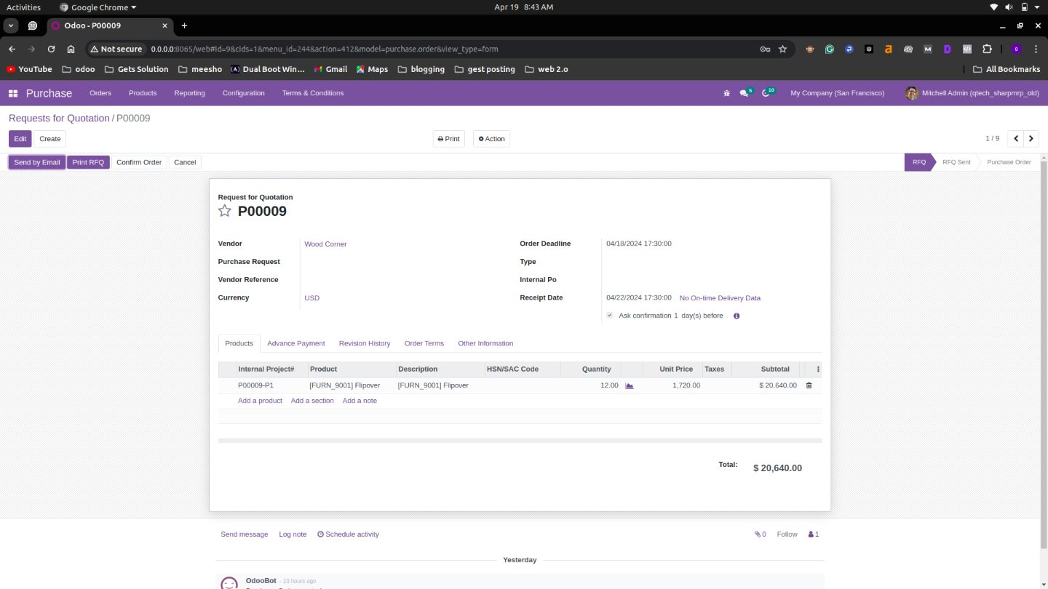

### Inventory view

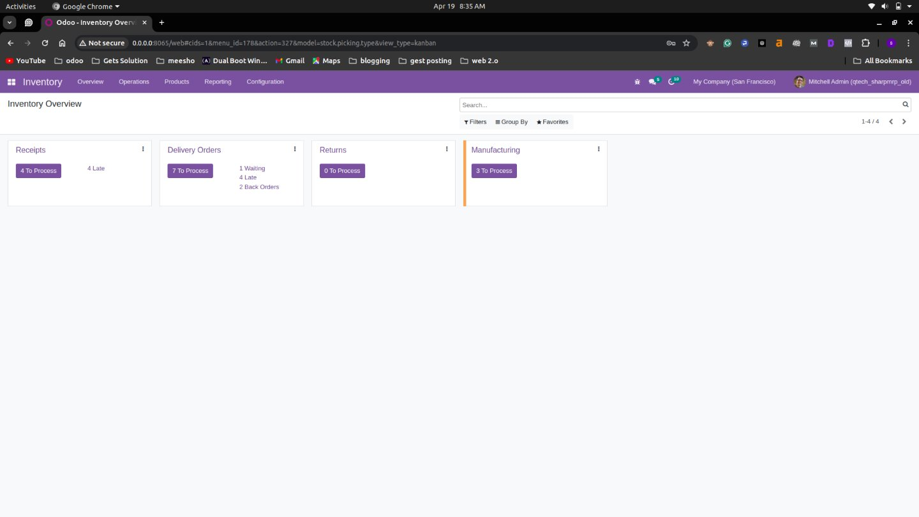

### CRM View

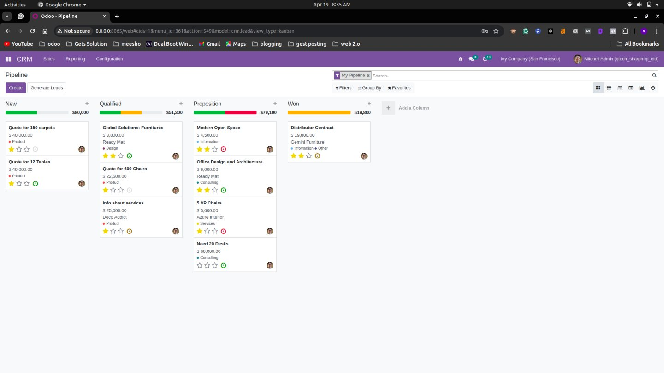

### Accounting view

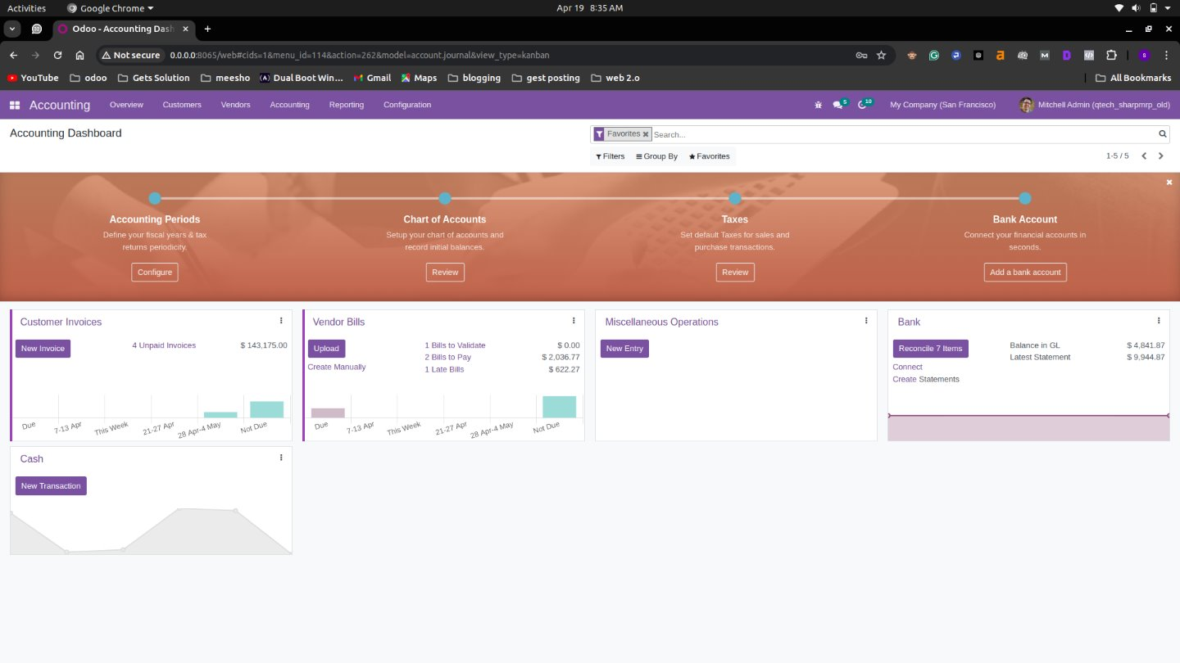

### Accounting form view

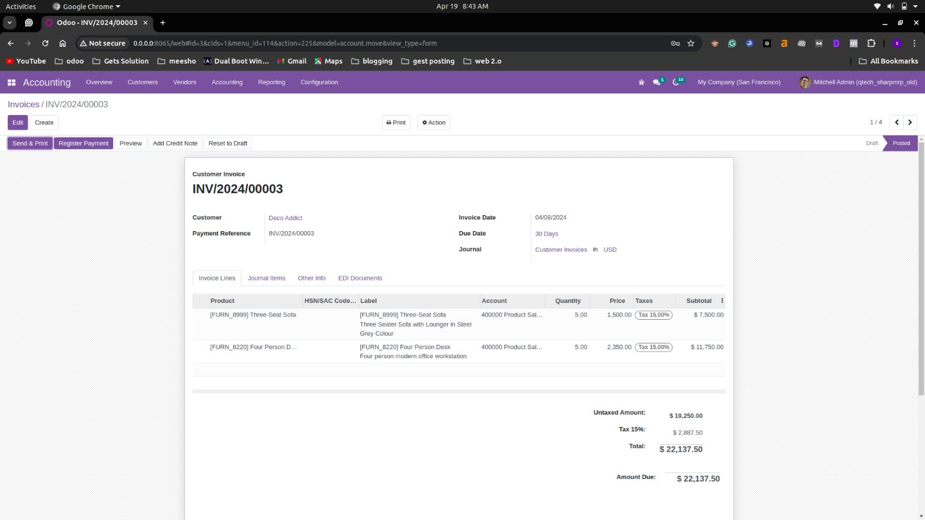

### Log view

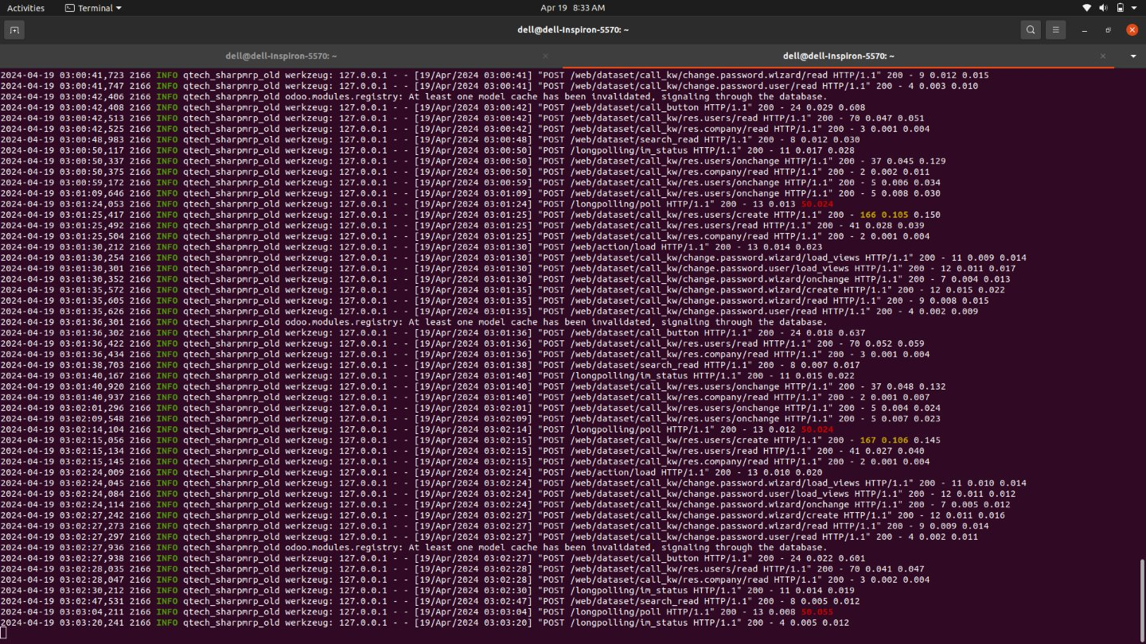

## **Visualization of Results**

### CRM Forcast

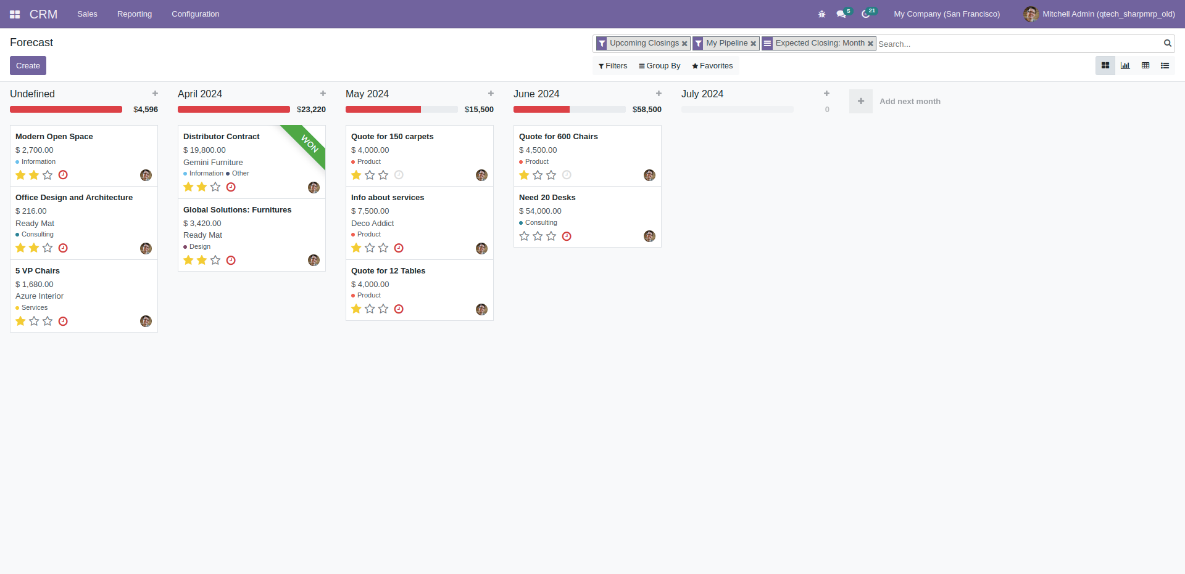

### 

### CRM Pipeline Analysis

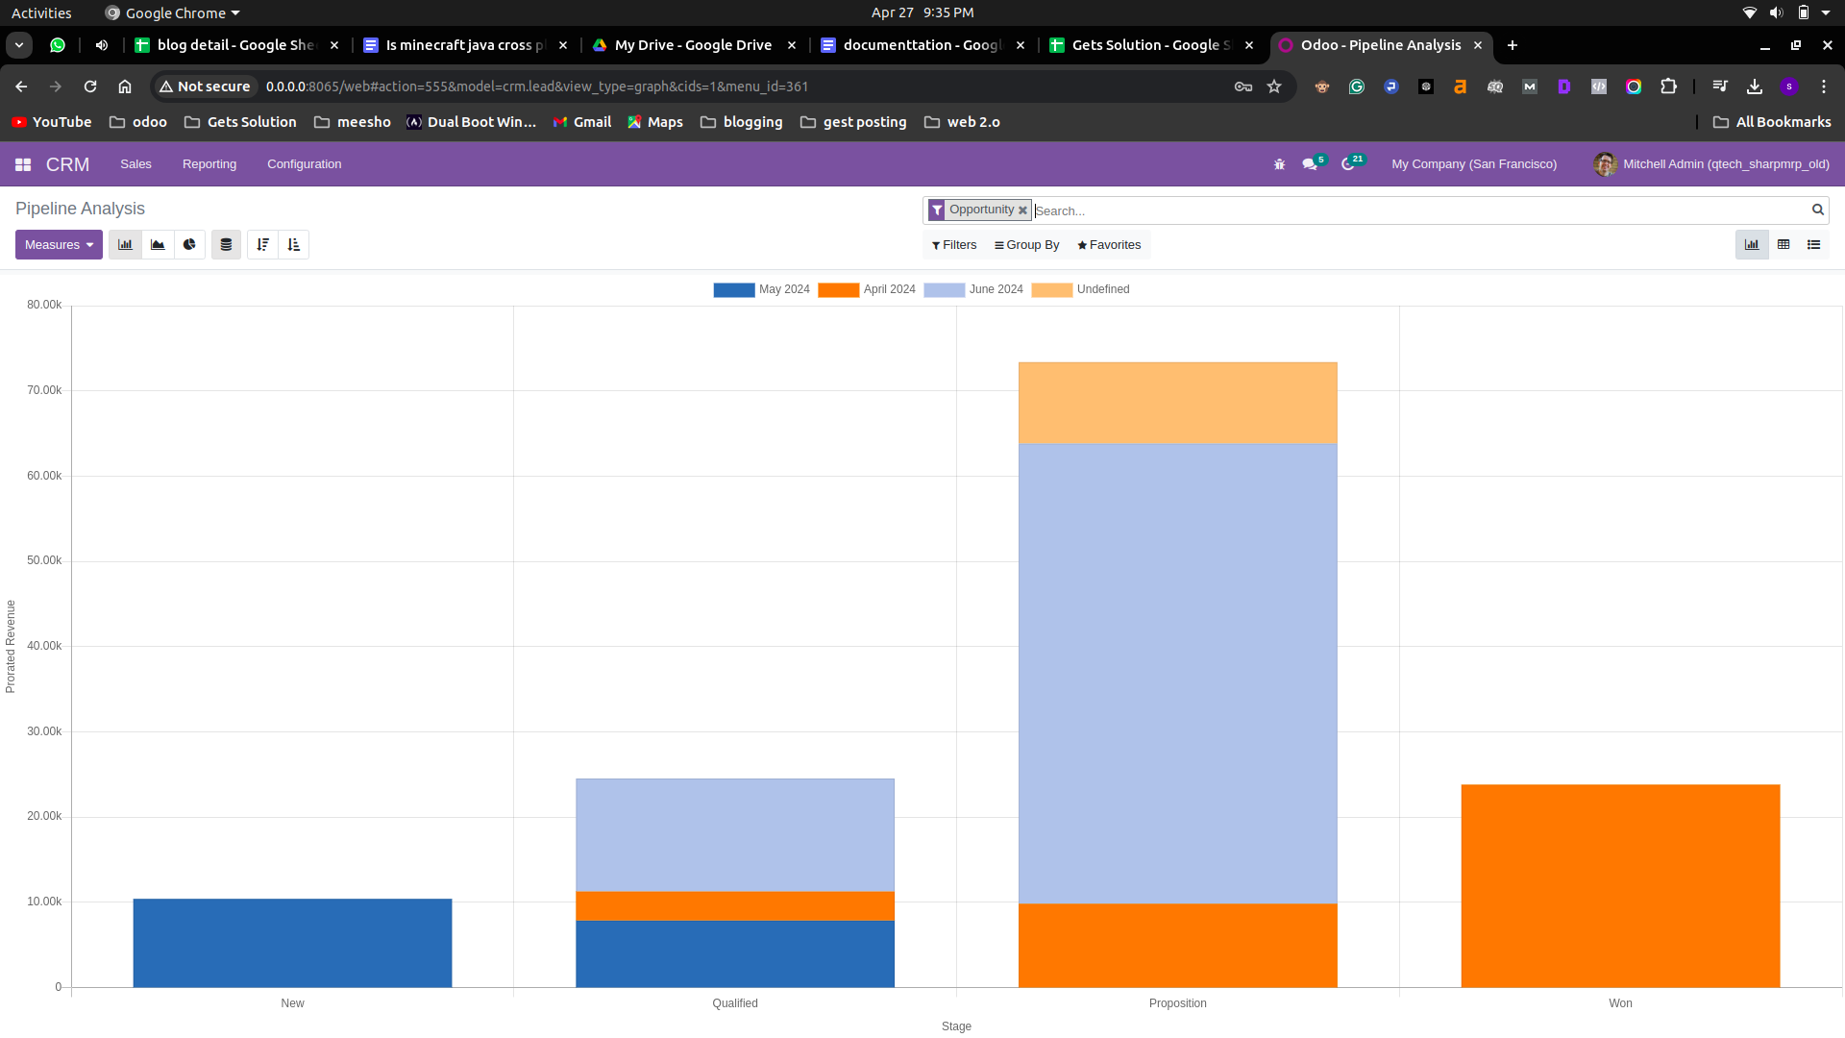

### SALE Report

### Purchase Report

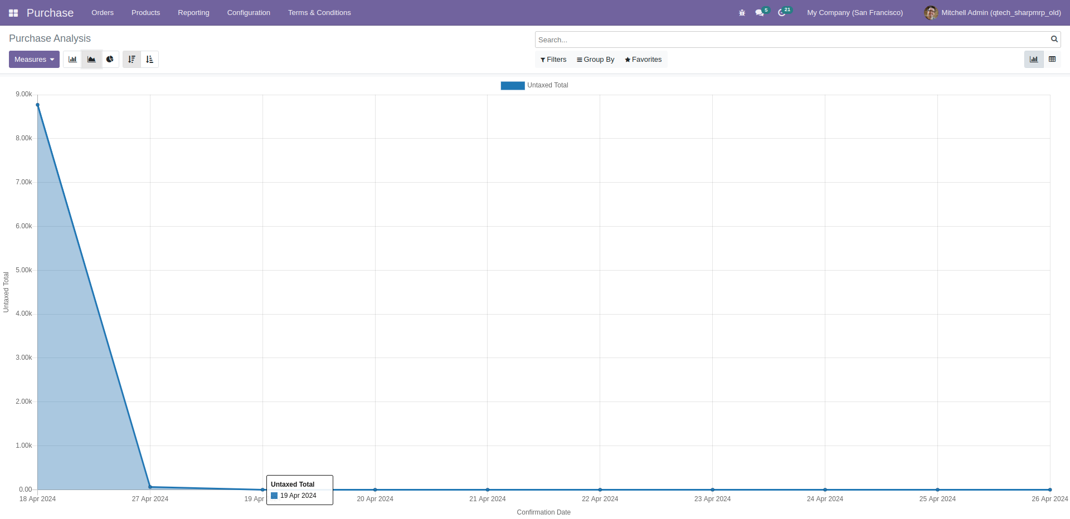

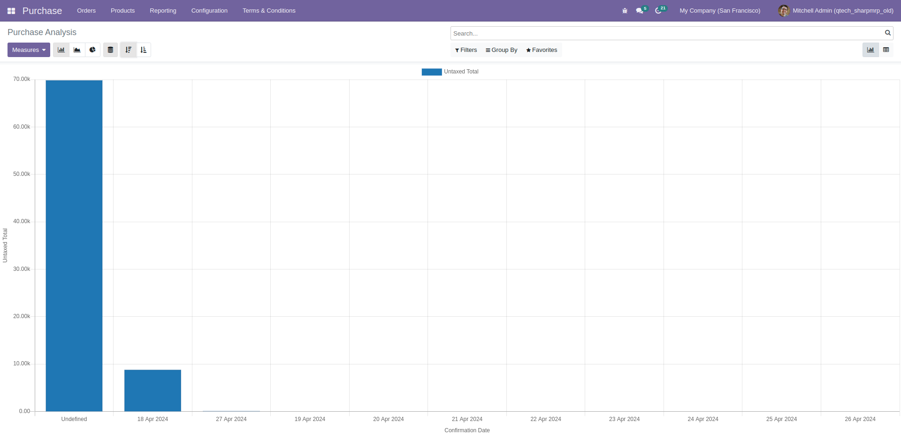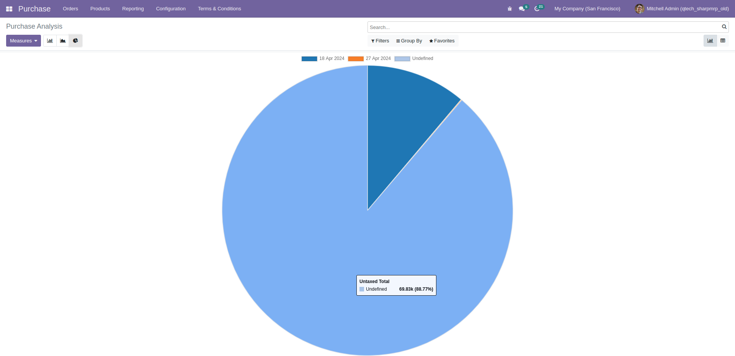

## 

## **Accounting Report**

### Accounting Report List

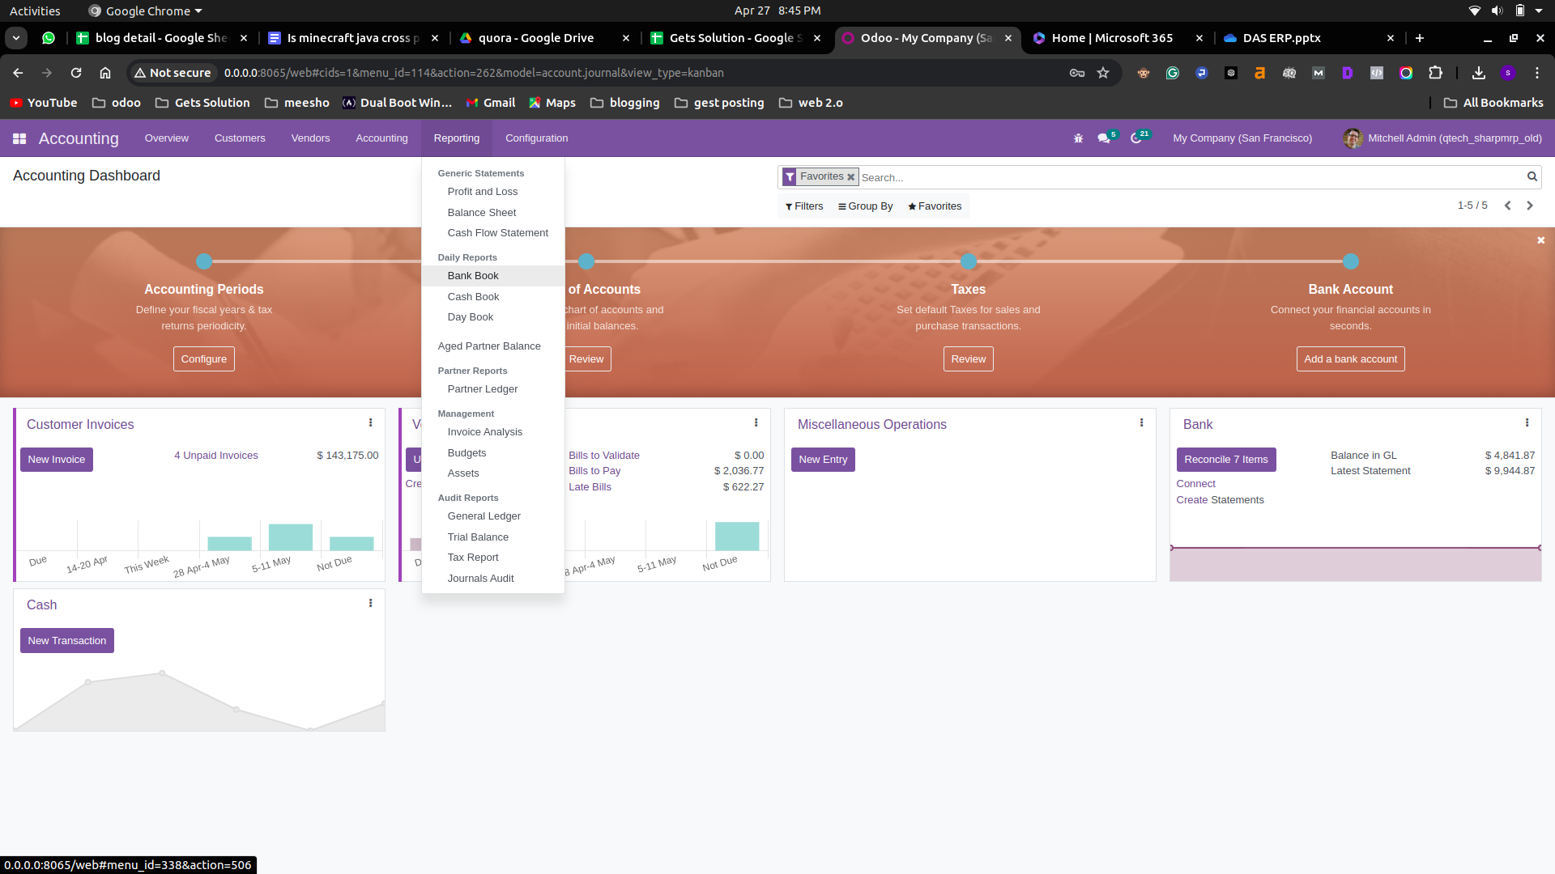

### Profit and Loss

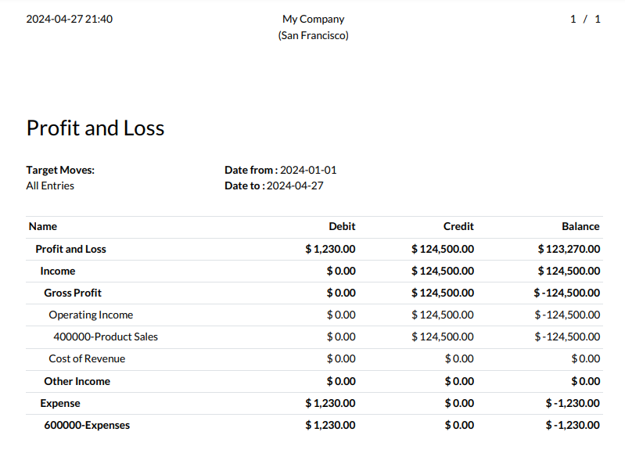

### Balance Sheet

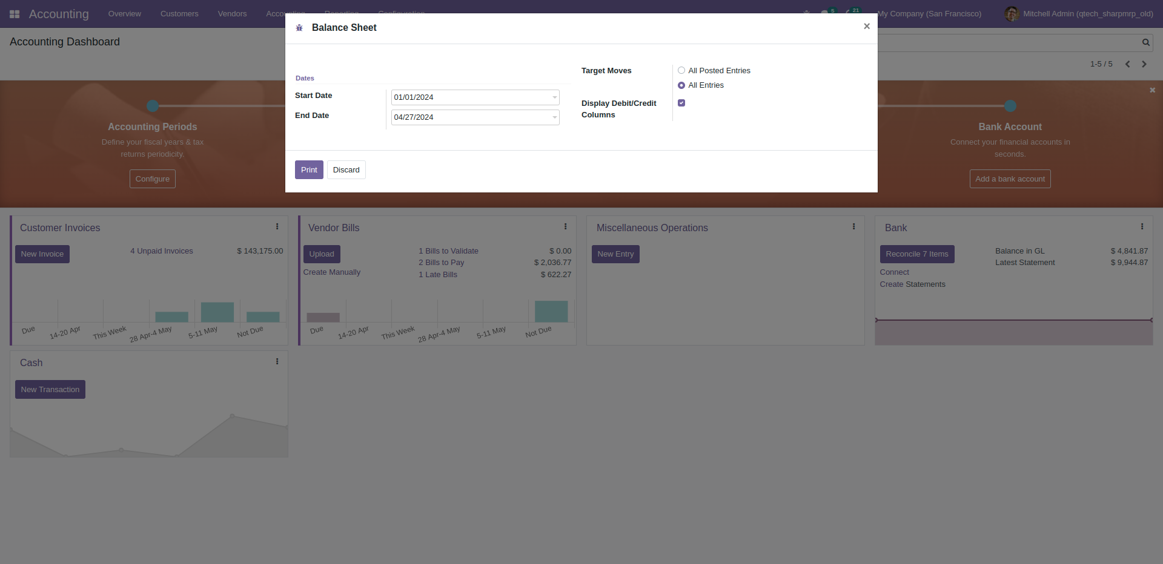

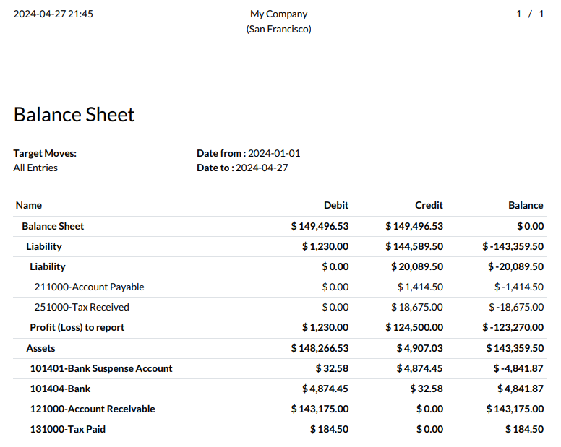

### Bank Book Report

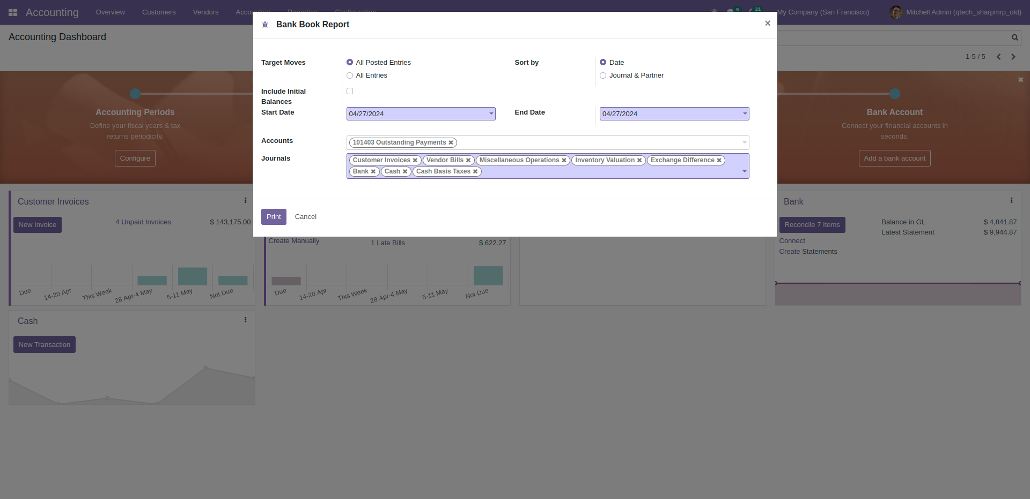

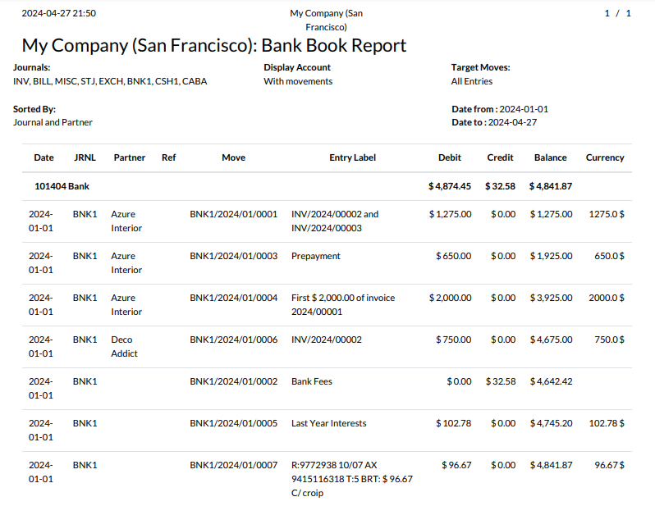

### Cash Book Report

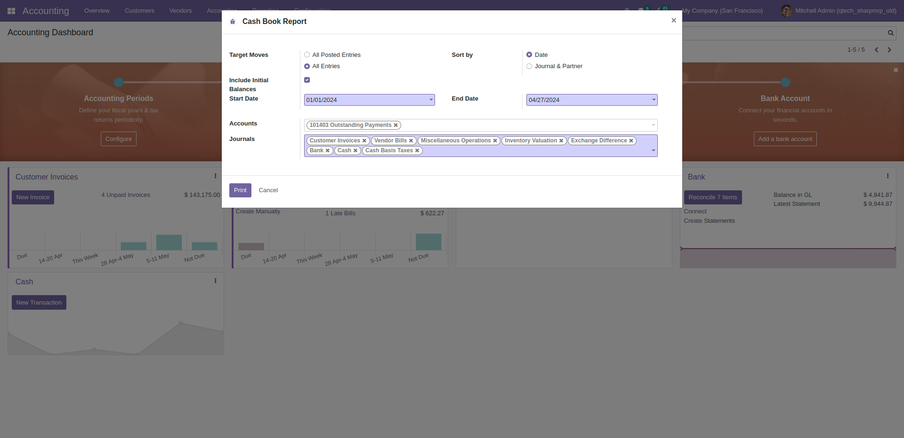

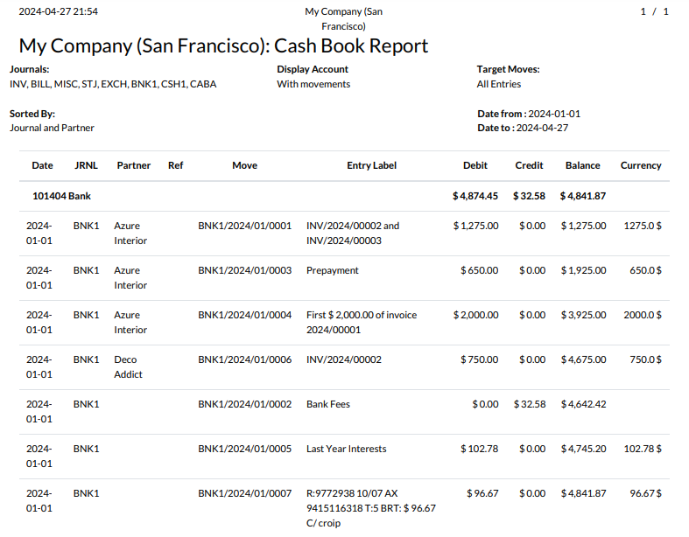

### Day Book Report

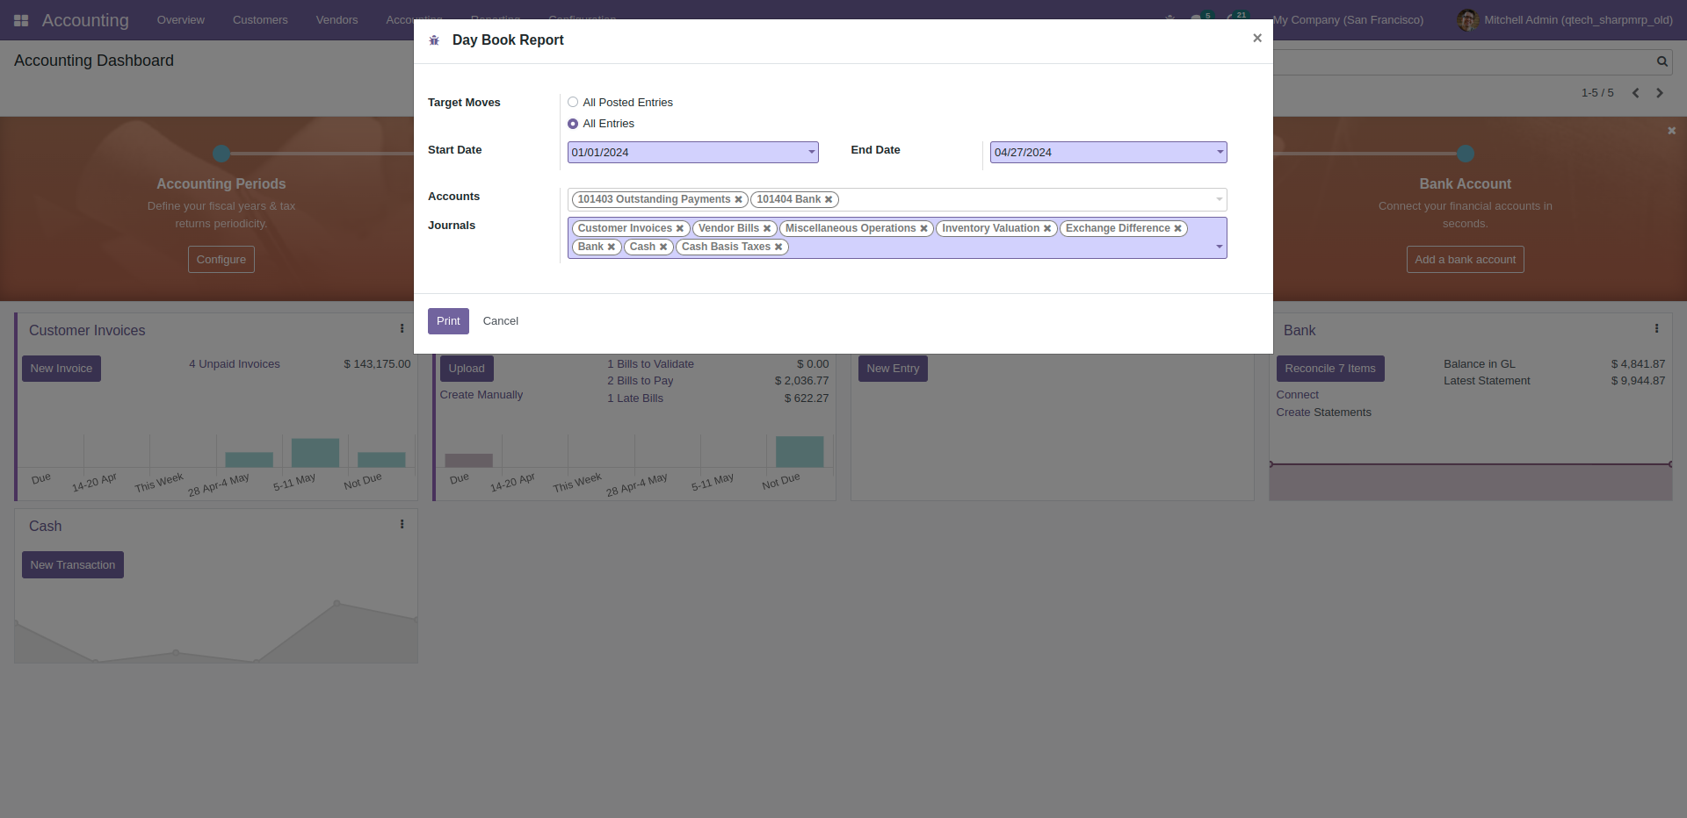

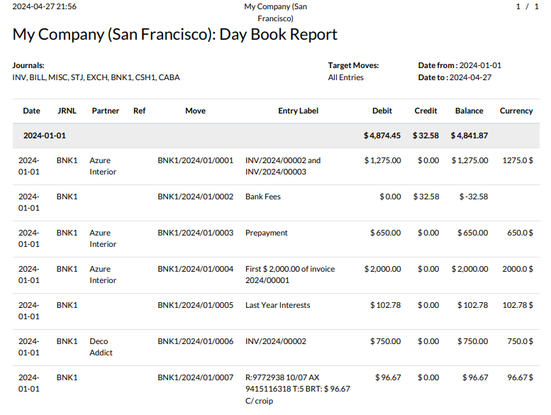

### Aged Partner Balance

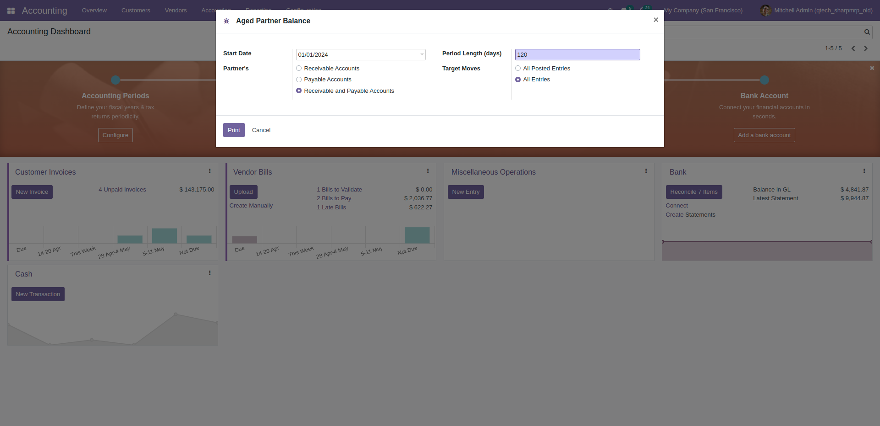

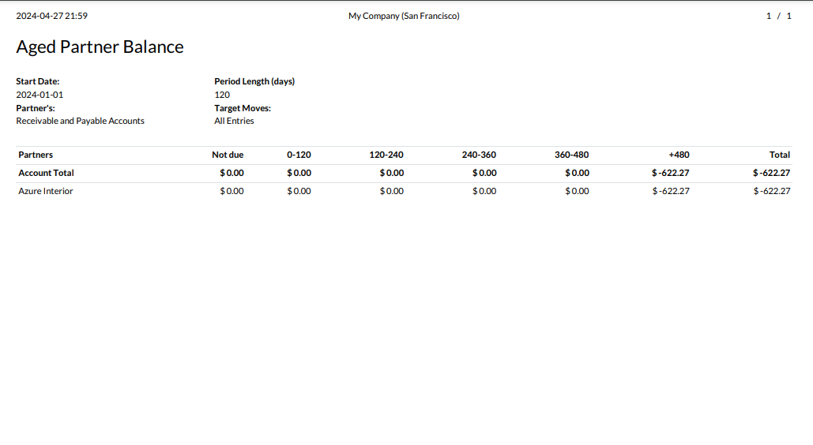

### Partner Ledger

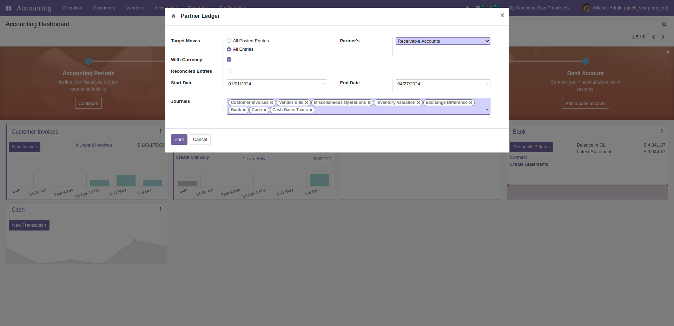

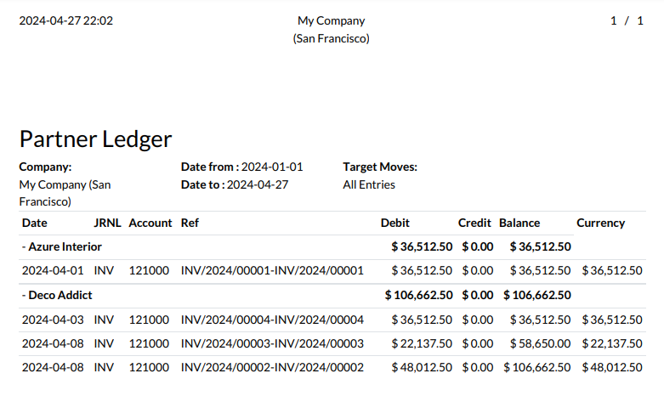

### General Ledger

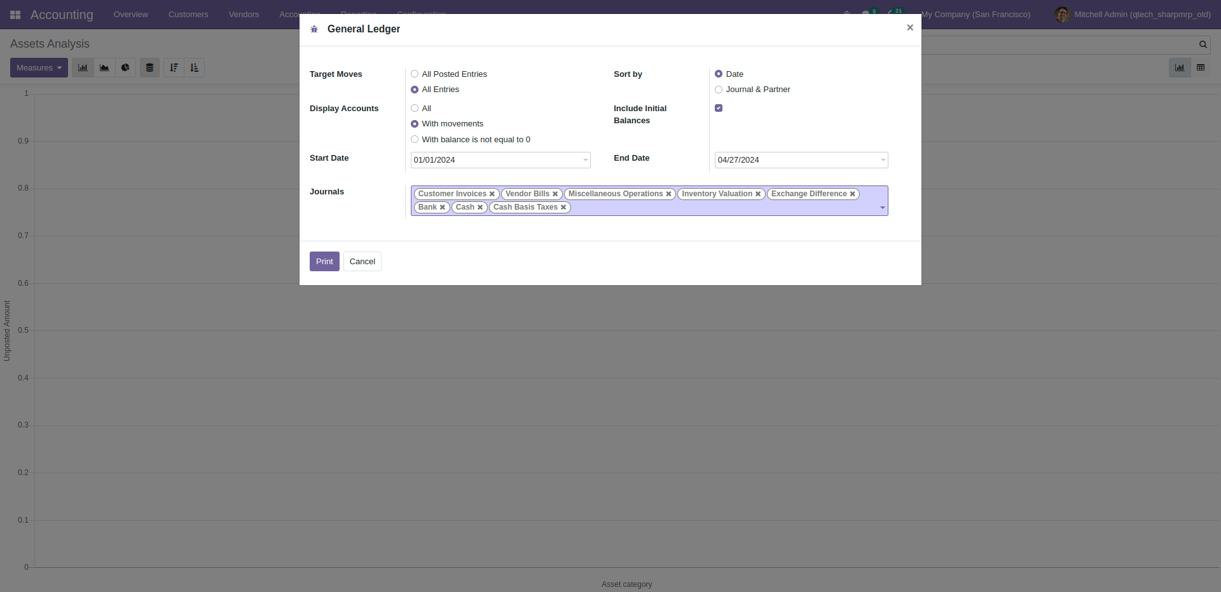

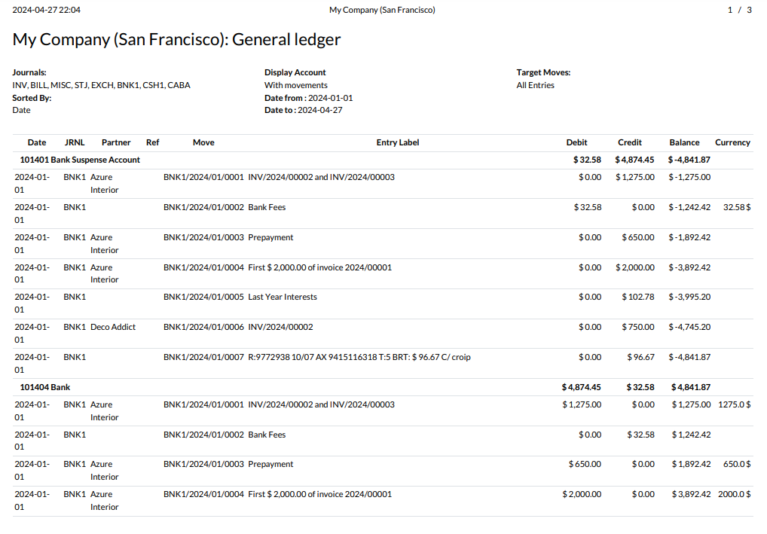

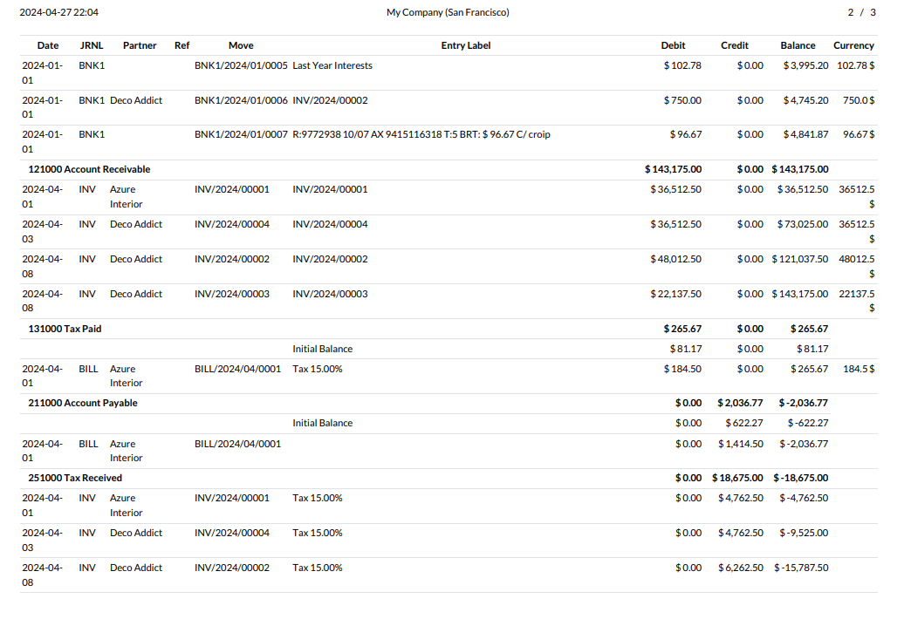

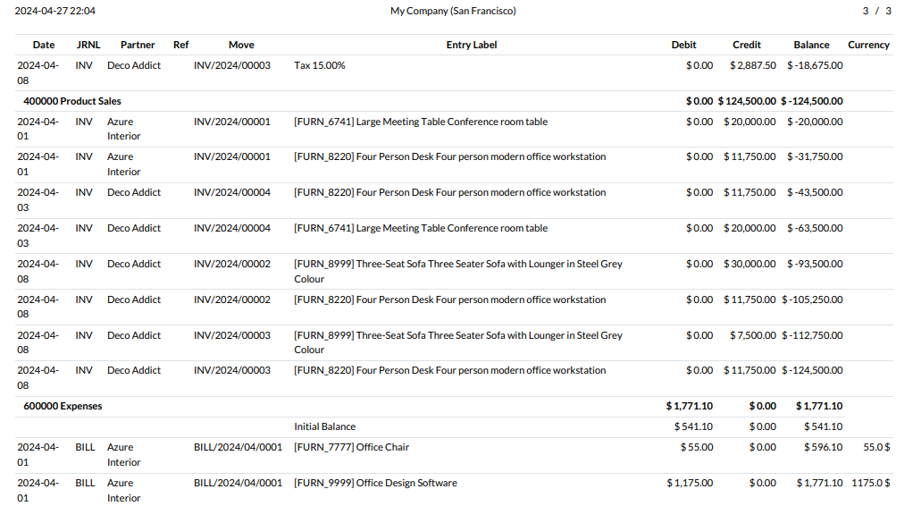

### Trial Balance

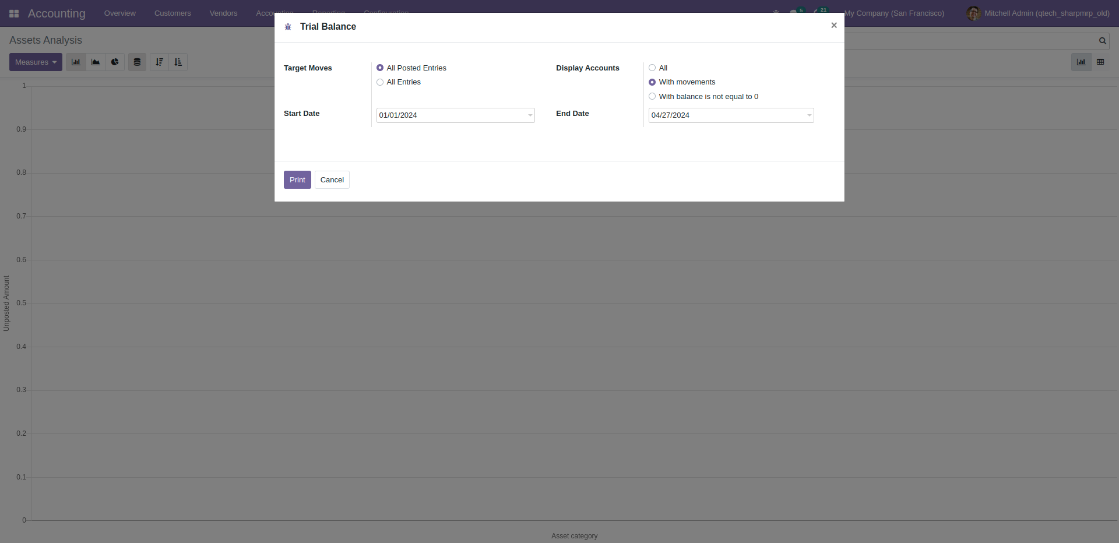

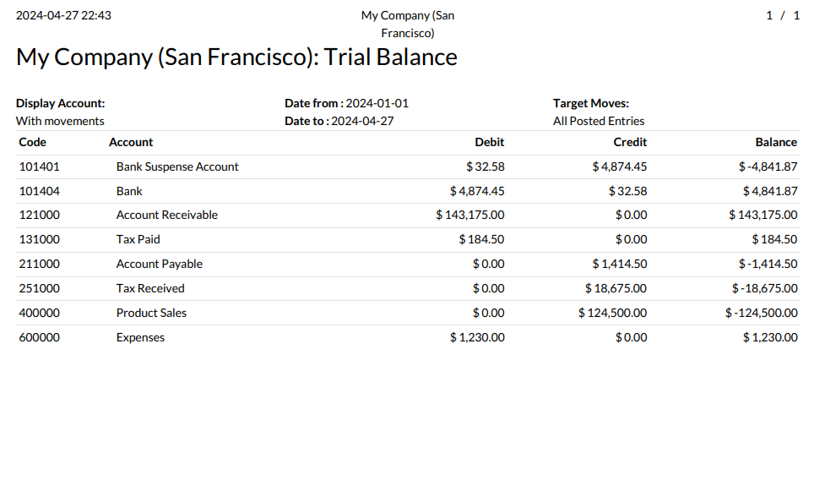

### Tax Reports

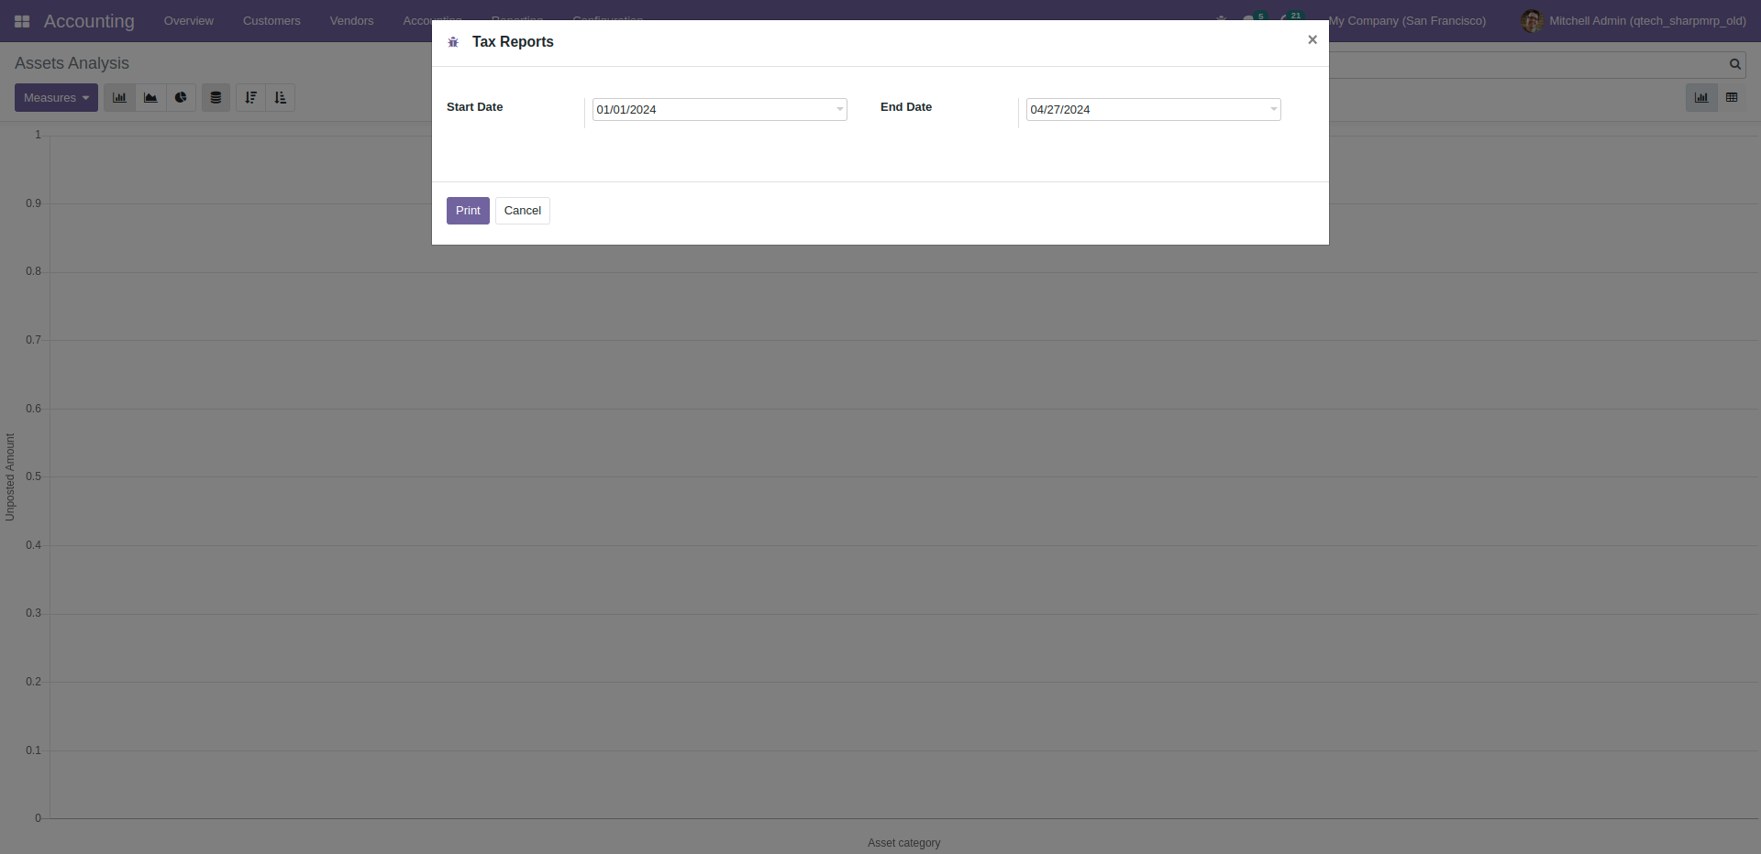

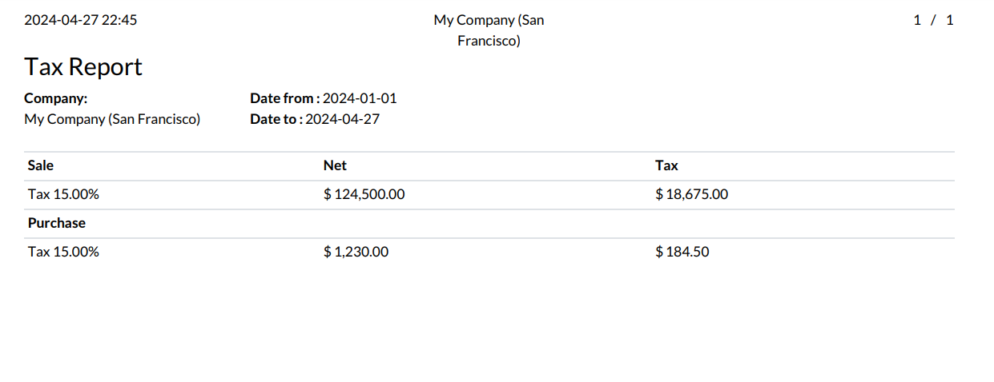

### Journals Audit

## **Inventory Report**

### Stock On Hand

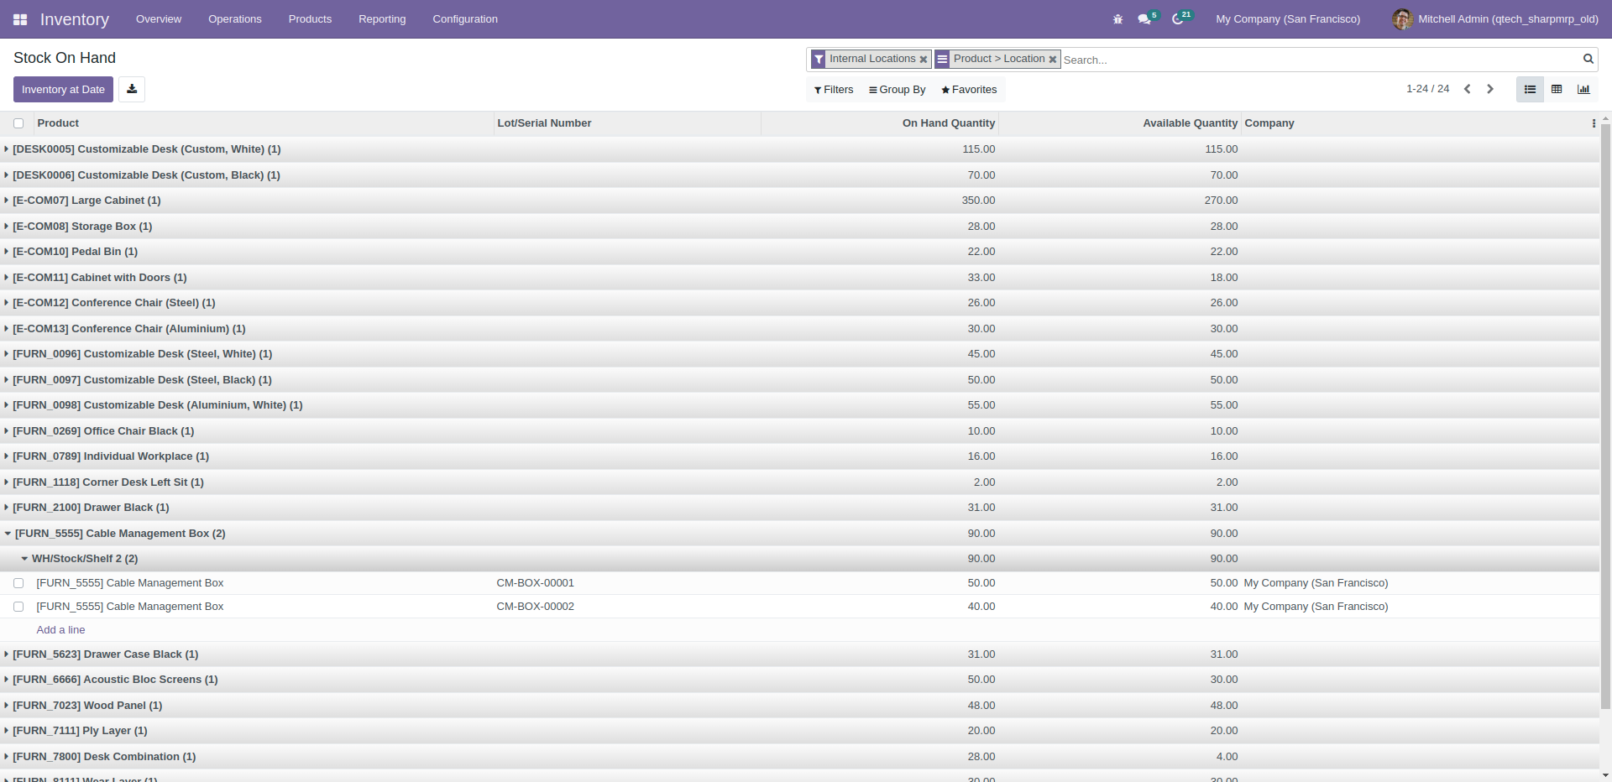

### Forecasted Inventory bar

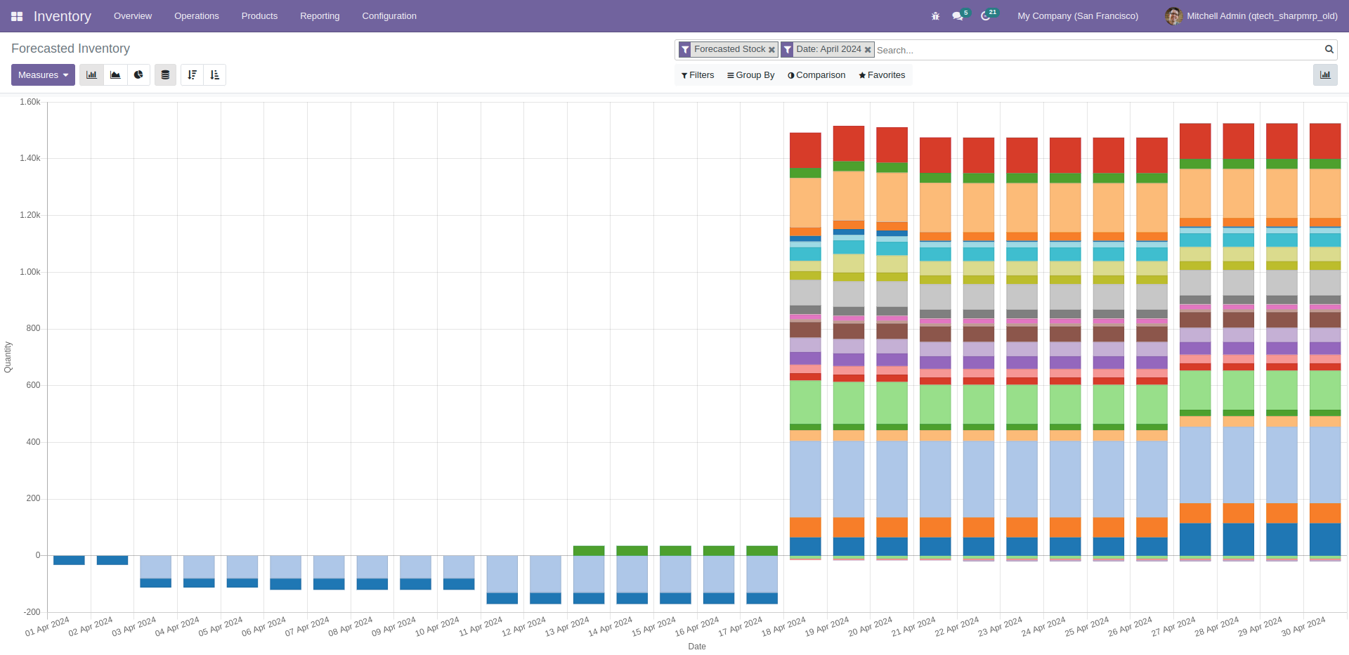

### Forecasted Inventory line

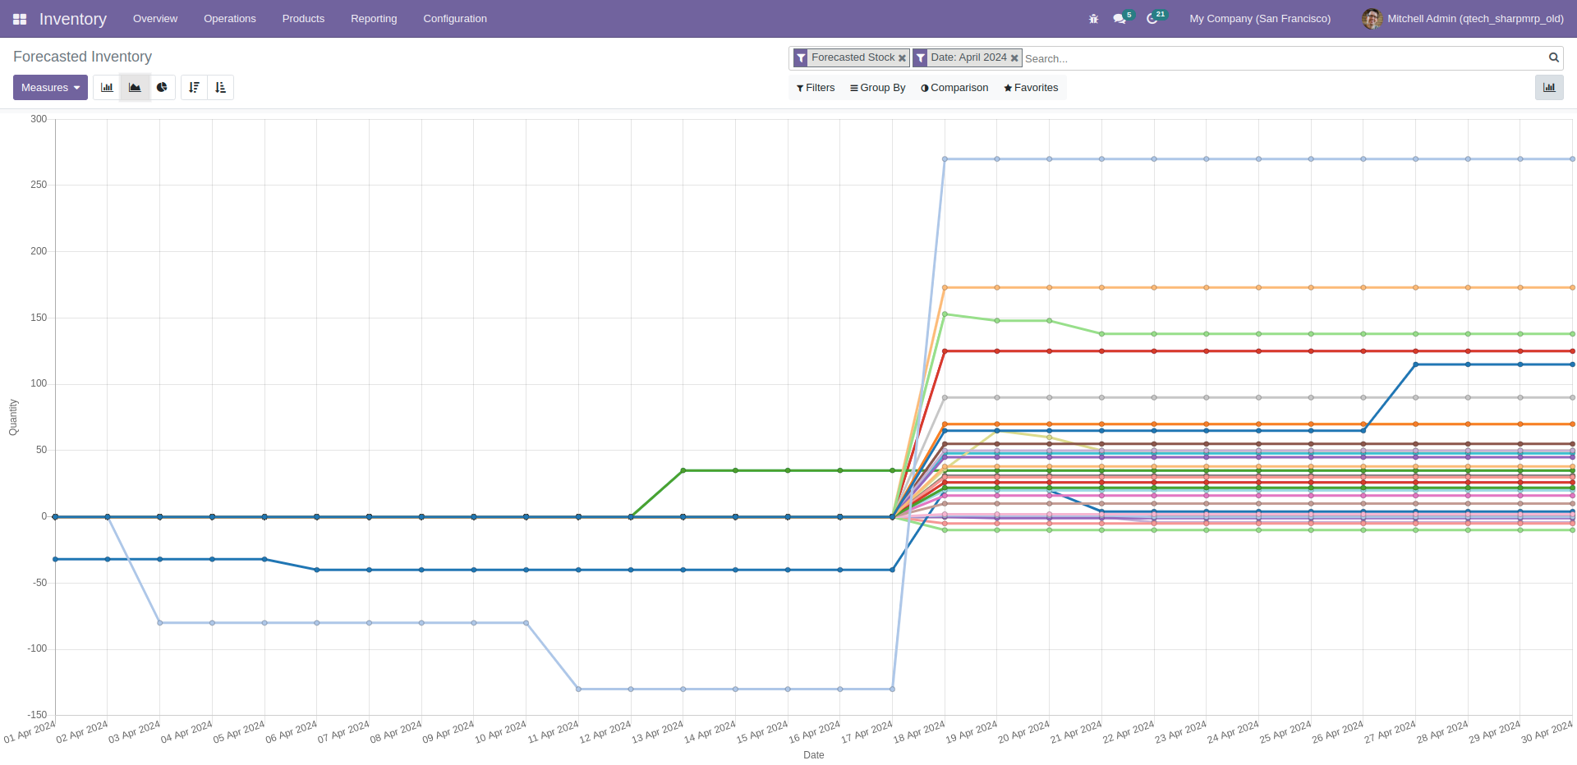

### Stock Valuation

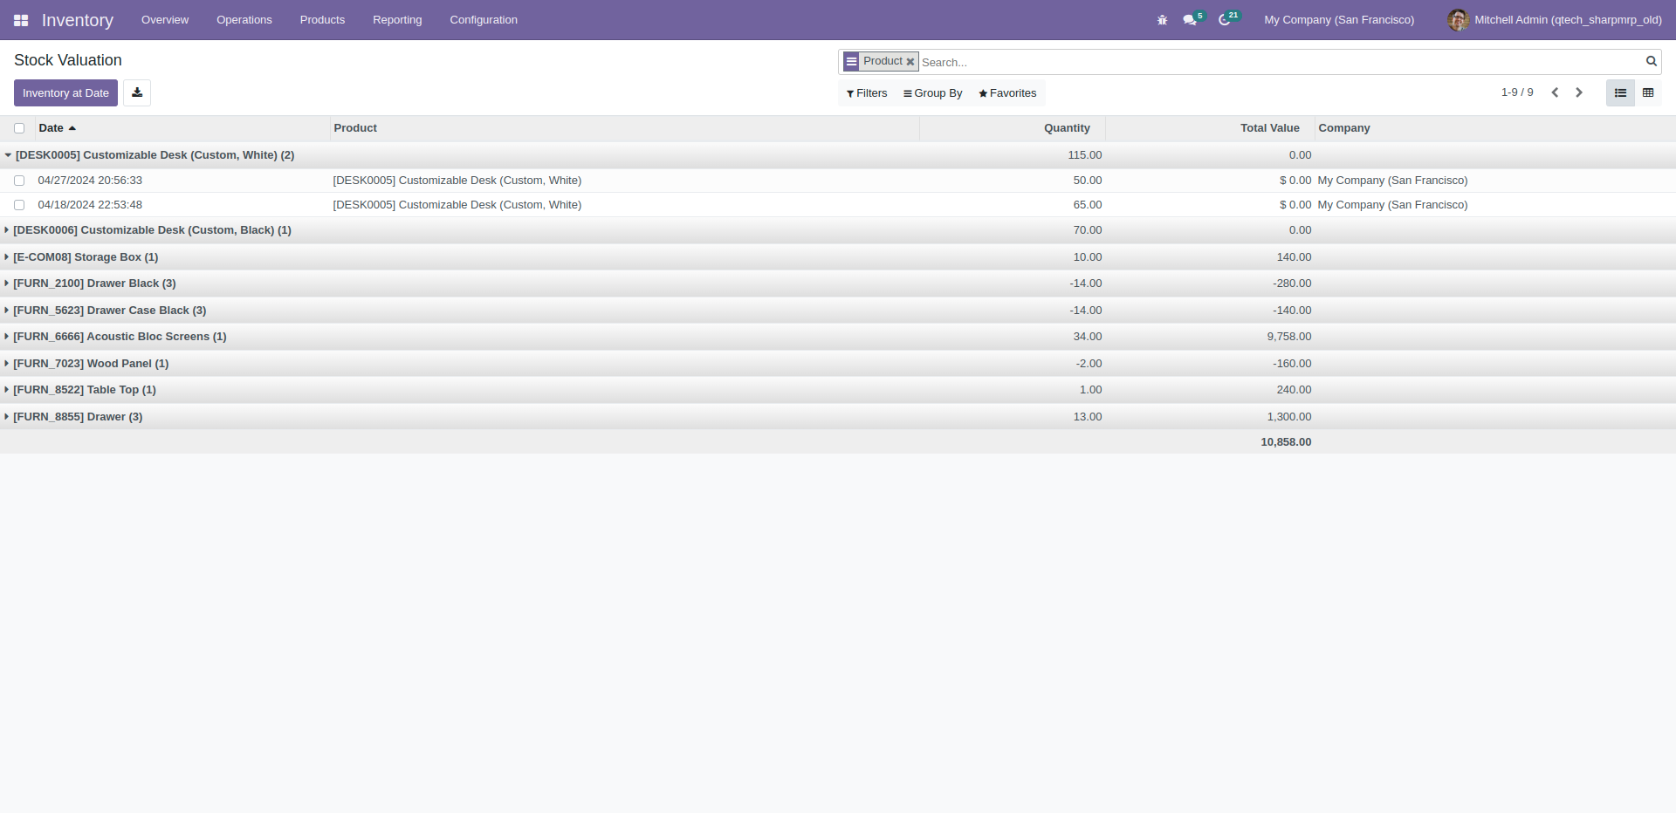

### Stock Moves

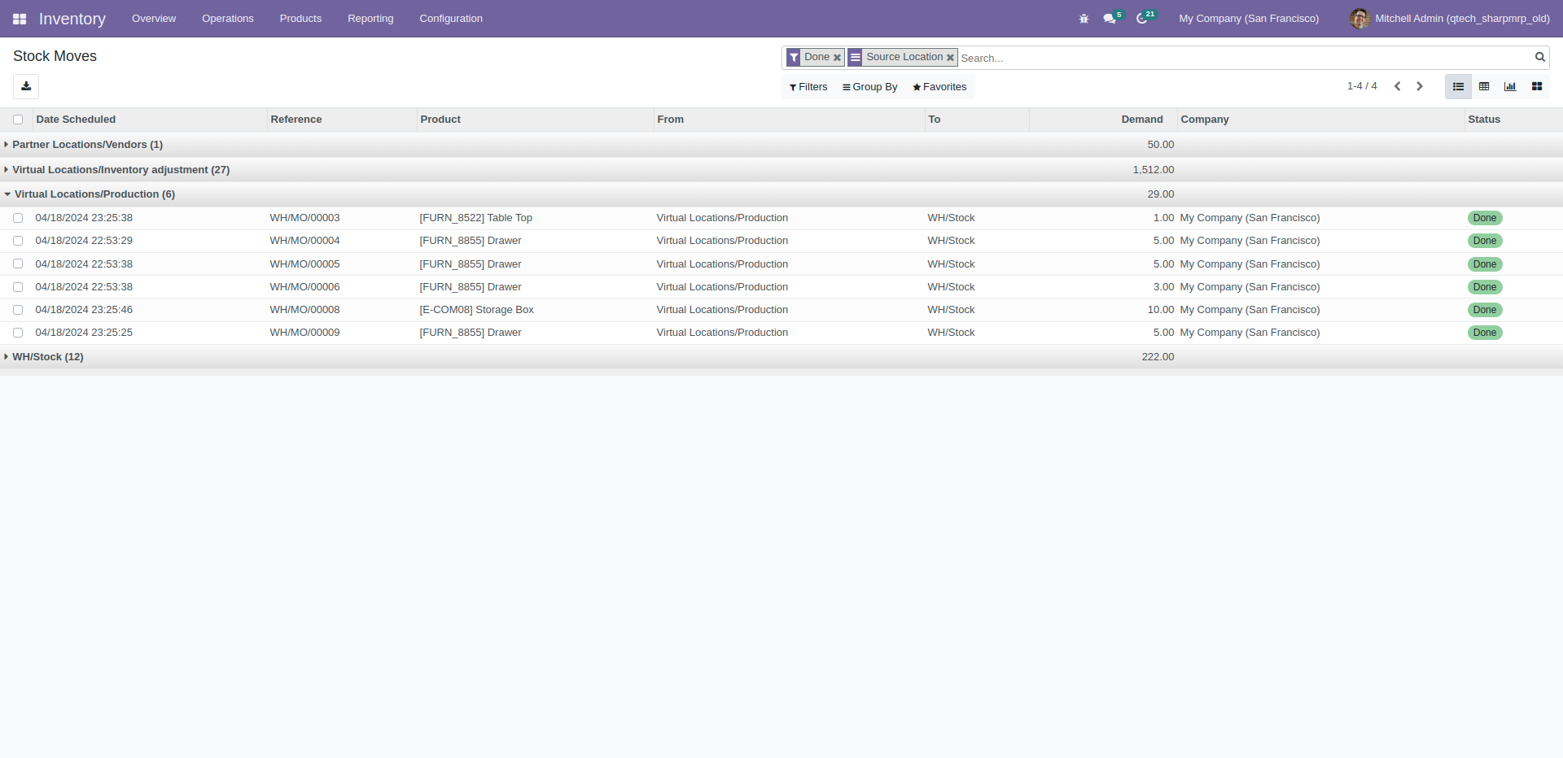

### Product Moves

